# CS 3331 Advance Object-Oriented Programming

# Spring 2020

## Lab Report #5

Author: Nichole Maldonado

Due: May 5, 2020

Professor: Dr. Oscar Mondragon

TA: Alireza Nouri

# Overview

Lab 5 Patterns, Collections, and Testing focused on using design patterns and Java Collections in our current chess applications from Lab 4. I used two design patterns for my lab: template pattern and Model View Controller (MVC). For my collections, I selected HashMaps, ArrayLists, Deques, Lists, and HashSets. In order to understand the importance of testing, Junit tests were applied to the most important methods of the new classes implemented. These tests will be outlined below.

# Design Pattern: Template Pattern

1. *Provide a brief description of your pattern*

The template pattern consists of an abstract class that has a final template method and abstract classes which the subclasses are supposed to implement. The template method is responsible for providing a skeleton of the code and calls the subclasses when needed to fill in the extra details. The ChessPiece class is the abstract class for my program. It contains the template method, move, which is final. The ChessPiece class also declares an abstract method called validMove which the subclasses must implement to provide the details. The Pawn, Rook, Queen, King, Knight, and Bishop, implement this validate method. However, I did alter the template method to achieve the best results. The Knight, Pawn, Rook, and Bishop all extend the ChessPiece. Unlike previous lab implementations they do not call the super for verification. In fact, this is one important aspect of the template pattern which is able to limit the subclasses and call them only when they are needed. The Queen extends the Rook and the King extends the Queen. I decided to make this minor change to reduce the amount of redundant code. Redefining methods in both the King and Queen would have resulted in more convoluted code. Although I did add an additional layer to the template method, it is still important to note that the template pattern is still utilized. The Queen and King cannot continue to call super indefinitely. Once they reach the Rook’s implementation, they stop. Thus, the ChessPiece still has control over each class and calls them when necessary.

1. *Explain why is important for your chess game*

I used the template pattern for the ChessPiece class, Rook, Pawn, Bishop, Knight, Queen, and King class. One of the main reasons why I selected the template pattern was due to the move method. The overall structure of the move method was the same throughout the Rook, Pawn, Bishop, Knight, Queen, and King class. First, checks need to be done to ensure that the piece is within the game, then new position would be validated based on the piece type. If the move was valid, then the piece’s position would be updated. Otherwise, the piece would stay in its current position. Thus, the overall skeleton of moving a piece is the same, the only difference is the details of the validate move that vary among the classes. Since the template pattern is used to define a skeleton algorithm and have subclasses override the detailed aspects, I decided to use this design pattern.

Compared to my previous lab, I like the template pattern implementation the most. Before, I would call the validate move function and then move the piece. However, by creating a single move template method that denoted the outline for the method, I think my code became easier to comprehend. I also think that this implementation is more flexible for future designs, since you could continue to add on steps and call the subclasses to provide specific implementations.

1. *Explain how you had to modify your code to adapt the pattern*

The adaptation from my original design to my new design was fairly straightforward. I created an additional move method in the ChessPiece class and made it final. I then went to all the inheriting classes and removed the calls to the super, except for Queen and King. In the move method, I called the validateMove method and then moved the piece. Originally, I had called the validMove method in the verifyAndInitiateMove method. However, I changed the method call to move instead and removed the call to the setters of the chess piece. In the template method, I also did some checks to make sure that the piece was actually moving and not just staying in a single position. Once these checks were made the subclasses were called to fill in the details for their own move.

1. *Provide the general UML diagram of the pattern listing each of the components. Do not include any chess classes. You will show it later.*

General Diagram

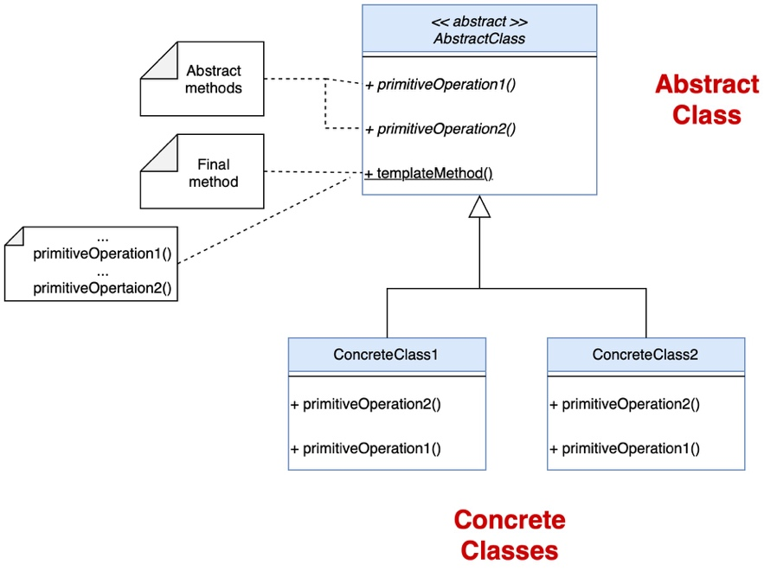

Chess Diagram Using Template Pattern – Although it states above not to include a chess UML, I have the two diagrams depicted below. As can be seen below, my chess program had many classes and I believe that the design pattern became lost in the diagram. Thus, I wanted to clearly represent the design pattern in its own UML.

The components for the template pattern design implementation are as follows:

* Abstract Class – ChessPiece
  + Template Method – move
  + Abstract Method – validMove
* Concrete Classes – Pawn, Rook, Queen, King, Bishop, Knight
  + All provide implementation for validMove

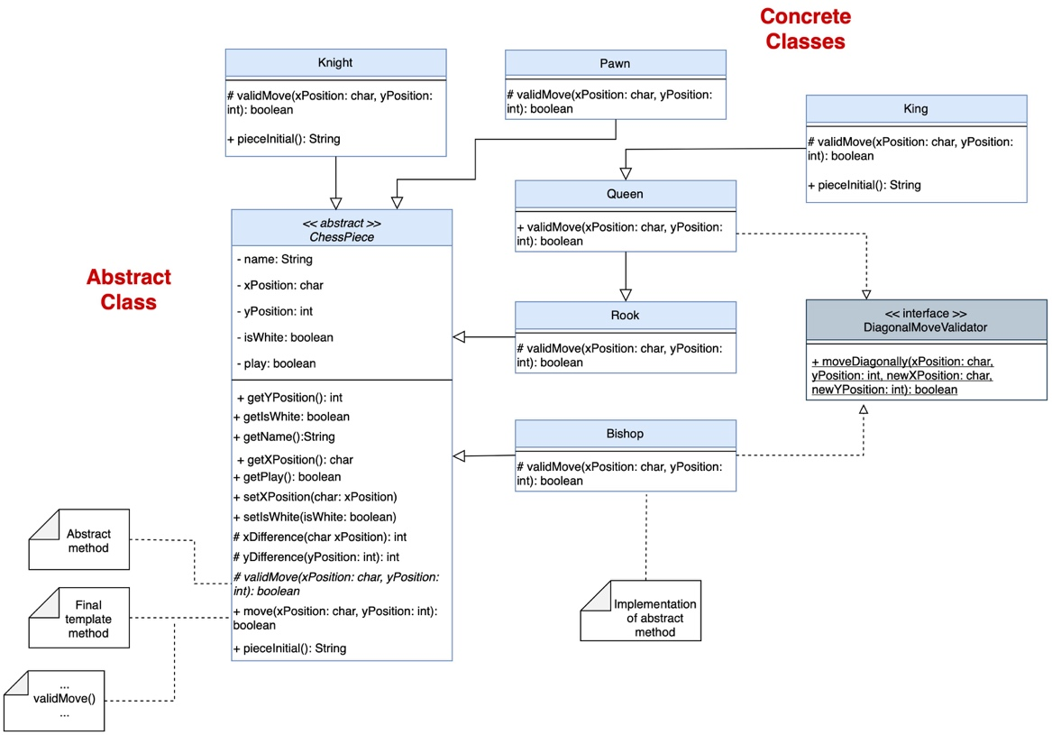

# Design Pattern: Model View Controller (MVC)

1. *Provide a brief description of your pattern*

The MVC design pattern is used to separate the controller, data, and presentation of data of an application. The controller is responsible for managing the view and model. The view is the user interface of the program and the model performs all the logic and holds the data. The model is also responsible for talking to external databases if they exist. For my implementation, the Game acts as the controller between the two. When the Game is called to start the game, it handles all user interaction through the GameView. Game tells GameView to collect the x and y position of the user. The game will get these positions and pass them to the GameModel who will then verify the moves and initiate them if they are valid. The GameModel has access to the chess pieces, because it references the ChessBoard. The GameModel is responsible for holding all the data, which are the chess pieces in this example. After the GameModel is done, the Game will then call the GameView to print the new chess board. I also moved the hasChat, timelimit, use auto save, and game id to the GameModel. When the user is selecting their game configurations, Game calls the GameView to get the user input and then passes that information to the GameModel to store.

1. *Explain why is important for your chess game*

Although this pattern is usually used applications with user interfaces, I thought it was necessary for my game renderings. For my lab, I redraw the chess board with the new chess pieces in their new positions. Prior to Lab 5, I had grouped the chess board printing in the ChessBoard class. I also combined the start game method with the other methods included in the Game class. In this start game method, I not only repeatedly drew the game but also computed if the moves were valid. The MVC, was the most optimal solution in my opinion. My code still functioned correctly without it, however, it felt jumbled together. I decided that the best way to remove the game display and logic was through the MVC design pattern.

Using the MVC pattern for my game really helped the overall structure of my program. Before the view and logic were all tangled, but the MVC allowed me to organize the code. I was going to use the MVC pattern throughout the entire program but realized that this would be unnecessary since a majority of the other classes ask and store certain pieces of information. The Game, GameModel, and GameView were essentially the only parts of the code that had widely varying responsibilities. If I were to try to use the MVC throughout my program, it would lead to a wide variety of views that would do simple tasks and, in my opinion, expand the number of classes without adding value to the overall program. The GameView and GameModel were the only instances in which the data and presentation were clearly different, leading to my implementation of the MVC.

1. *Explain how you had to modify your code to adapt the pattern*

Originally, I had a single Game class that did all of the methods defined in the GameView and GameModel. In order to implement the MVC pattern, I relocated and refactored the code. In some instances, this was very simple. For example, the drawGame method just had to be relocated. As for the startGame method, this was the most intricate method that I had to work on. It had multiple instances of the view and model interweaved in it. Since it is crucial that the view and model only communicate through the controller, I had to create a custom exception that would signify if a piece was attempted to be moved where another piece already existed in the verifyAndInitiateMove method.

1. *Provide the general UML diagram of the pattern listing each of the components. Do not include any chess classes. You will show it latter.*

General UML

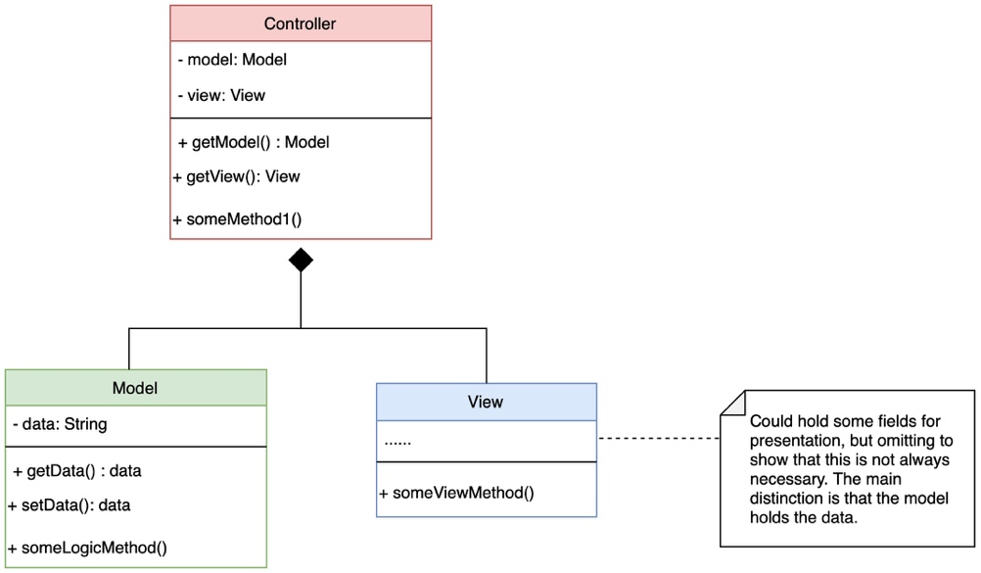

Chess Program using MVC

The components for the MVC template pattern design are as follows:

* Controller – Game
* View – GameView
* Model – GameModel
  + Data – ChessBoard, ChessPiece

NOTE: I included the ChessBoard and ChessPiece in this diagram since the Model stores the ChessBoard, and consequently the chess pieces as data. However, it is important to note that the most important parts of the MVC design pattern are the Controller, View, and Model.

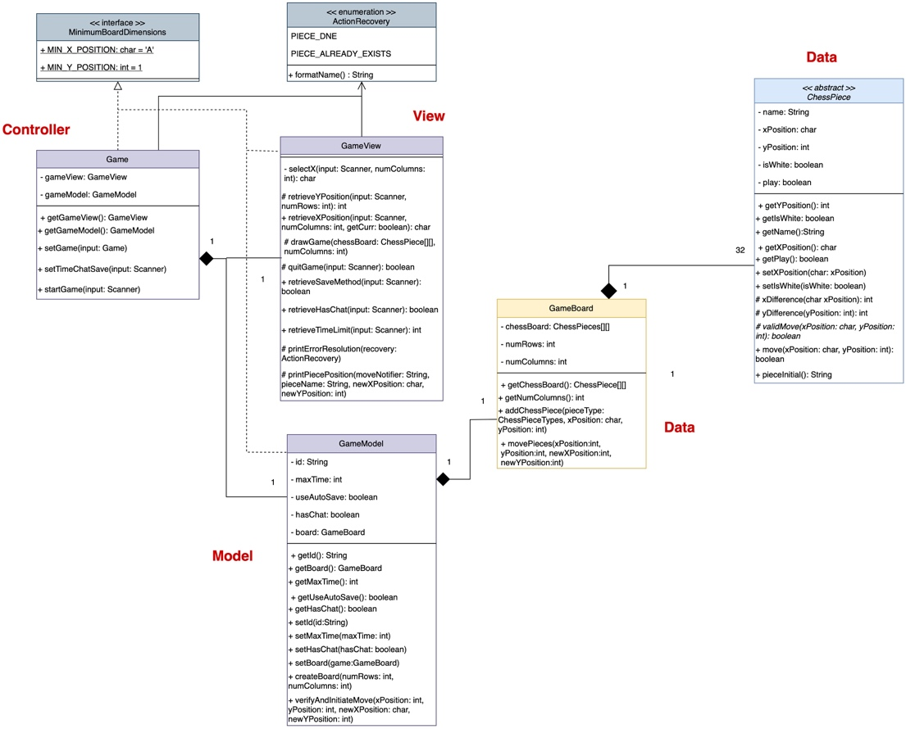

# UML diagram of your system

# *Provide the UML diagram of your whole system* ***including your new design pattern****. Make sure that your diagram includes: [X] You must add notes to identify each of the design patterns components. [X] Interfaces has methods. [X ] Classes has all fields and methods. [X] Inherited classes and interfaces shall not include methods from parent classes*

Figure 1 below depicts the class diagram for my lab, demonstrating the aggregation and composition relationships between the classes. Figure 2 depicts the class diagram demonstrating the association relationships. However, it is important to note that both diagrams depict the inheritance relationships, implementation of interfaces, and use of enumerations. In both figures, I have the ChessPiece abstract class. This class uses the template method, which will be later discussed. It is important to note that all six types of chess pieces extend the abstract class. Additionally, in previous labs it was questioned how the diagonal moves could be implemented and reduce code redundancy. I, therefore, created a DiagonalMoveValidator interface which includes a default method that checks diagonal moves. Thus, the Queen and Bishop classes were able to implement the interface and consequently reuse the code. The Controller is the main class in my program. It is responsible for maintaining a reference of the ChessPlayer, Parser, and Game. The Parser class is divided into two classes, ParserReader and ParserWriter. The Parser class owns a reference to ParserReader and ParserWriter only. The Controller will usually call Parser to issue some command, then Parser determines which parser to call. Figure 1 also demonstrates the FilePaths class. ParserReader and ParserWriter are two of the main classes that have reference to the FilePaths class. However, it should be noted that in the implementation, I used dependency injection to ensure that both ParserReader and ParserWriter refer to the same FilePaths instance. Figure 1 also depicts the Game, GameView, and GameModel. These three classes represent the MVC design pattern that I implemented. This will be discussed more in detail, but it is important to note that the Game acts like the controller. Thus, it owns a reference to the GameView and GameModel. If the Game class were ever to not exist, these classes would die with it. One other change that I implemented was the GameBoard. The GameModel is responsible for holding all the data, so I moved the GameModel to own the GameBoard rather than the Game, as can be seen in Figure 1. Lastly the GameDeleter and GameSelector were two new classes. I added the functionality to allow users to select from 3 of their most recently played games. Once the user has more than 7 games, they must delete at least one game. The GameSelector is responsible for determine whether an existing user wants to load a game or create a new game. If their game limit is reached, then the GameSelector creates a GameDeleter instance. Figure 1 also depicts a PasswordManager who is owned by the UserCreator. The PasswordManager is created before a ChessPlayer is made in order to verify the user’s credentials.

As for the association relationship represented in Figure 2, some important relationships would include that of the Game, GameView, and GameModel. The Game is always issuing commands to the GameView to display something or retrieves user input from the GameView. The Game also issues request for data from the GameModel and calls the GameModel to deal with the logical parts of the code. Thus, the Game has a unary association with both the GameModel and GameView since they never once call the Game. One example of a binary association relationship would be between the GameSelector and GameDeleter. When the GameSelector learns that a user’s game needs to be deleted, it creates a GameDeleter and calls on the GameDeleter. The GameSelector, however, passes an instance of itself. Thus, the GameDeleter uses the GameSelector to access the FilePaths and the user keys. The next interesting association depicted in Figure 2 is the association relationships for the FilePaths. It is crucial to note that the FilePaths does not communicate with any class. It only is responsible for holding a reference to the XML files. Classes such as ParserWriter and ParserReader constantly communicate with FilePaths to extract the needed XML file paths. As for the ParserReader, it also communicates with the ChessPlayer and UserCreator class. The ParserReader is responsible for creating a ChessPlayer from the user file and thus calls UserCreator to do so after collecting all the necessary elements. Figure 2 also demonstrates the association relationship between the PasswordManager and UserCreator. The UserCreator asks the PasswordManager to verify and collect the password. Lastly, the Controller’s overall association is very crucial. The Controller will usually talk to a “representative” of a group of subclasses, who is then responsible for communicating the information with the other classes. For example, the Controller calls the Parser, who will delegate jobs to the ParserReader or ParserWriter. The Controller will also talk to the Game, who will further divide tasks among the GameView and GameModel

Figure 1: Aggregation UML Diagram

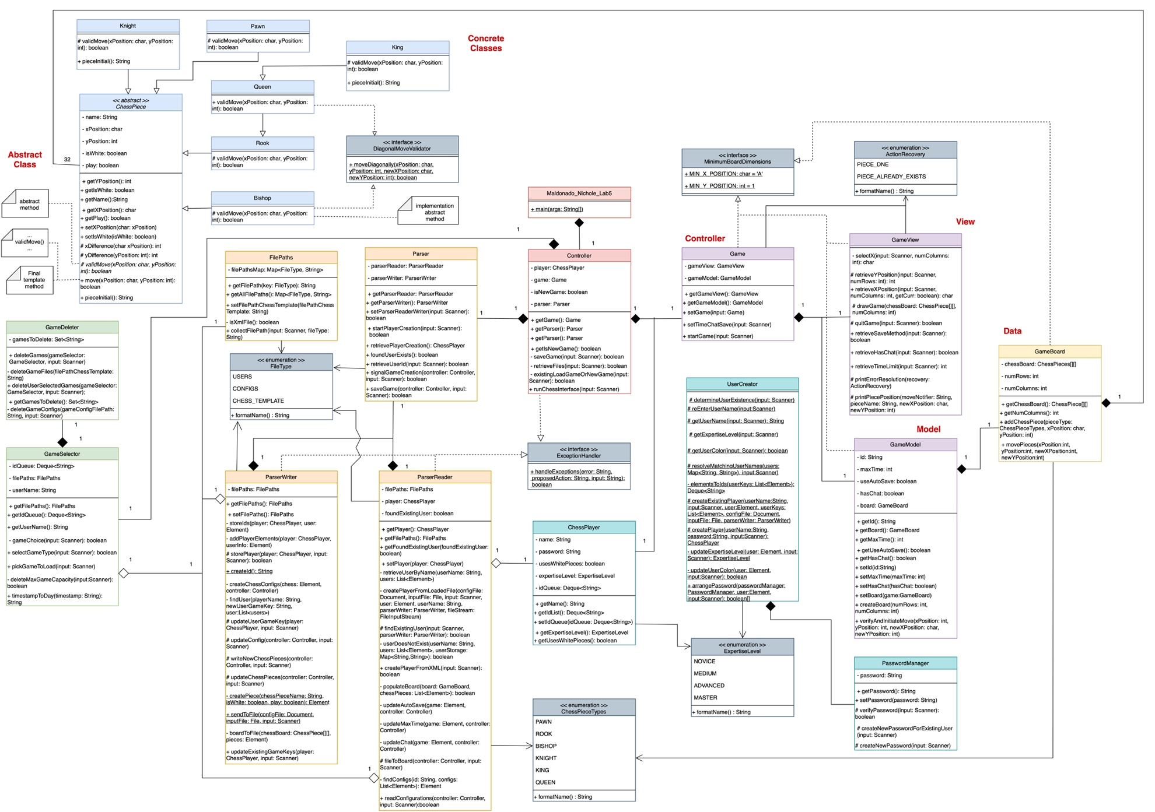

Figure 2: Association UML Diagram

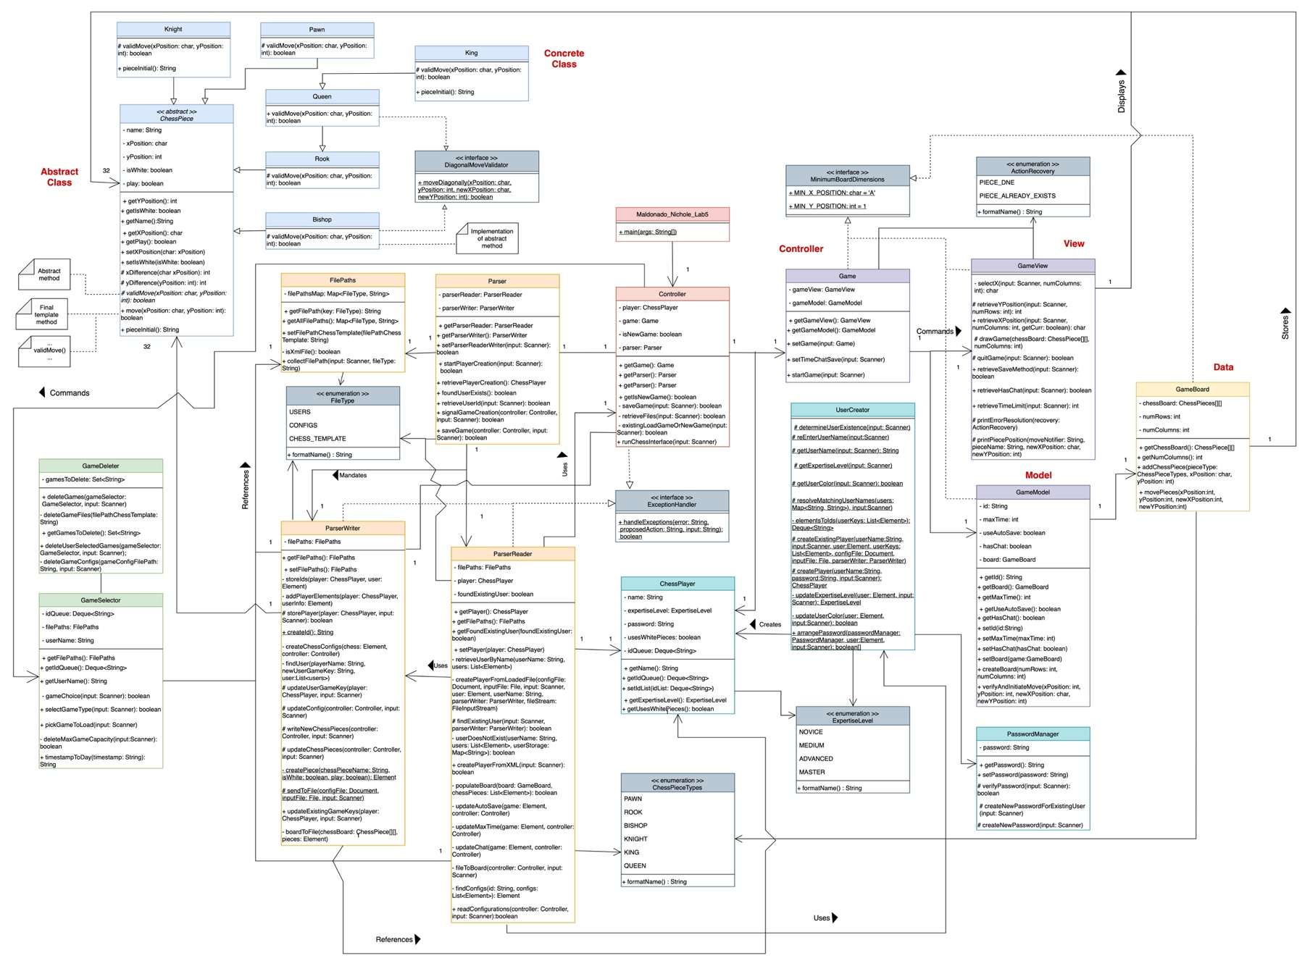

Java Collections

Collection 1.a: HashMap

1. I selected the HashMap in my code to store the usernames and passwords. If a user stated that they were an existing user, they would enter their username. While ParserReader was searching for the username, it would parse the usernames seen. Since all usernames need to be unique, the usernames were the keys and the passwords were the values. Thus, if the username was never found, the user could continue to enter a username and the collection would be checked to see if a matching username exists. When creating a new user, the user enters their new username. ParserReader iterates through all the elements to see if the username already exists. While doing so, ParserReader hashes the passwords based on the names. This is crucial because the username could already exist. In which case, the user would have to repeatedly enter their name until they find a username not already taken. I decided to use a HashMap since searches can be achieved in constant time. Additionally, HashMaps do not allow for duplicate keys. Since there cannot be duplicate usernames, I thought that using the HashMaps would be the most ideal. Additionally, the order of the usernames does not matter which is why I also chose a HashMap.
2. Traversals:

* Not used for traversals, mostly used to see if a key existed and to get the password based on the username.

1. Collection Operations:

* containsKey() – used in UserCreator, resolveMatchinUserNames. Each time a user entered a username, the map was checked to see if the username was in the collection.
* put() – used in ParserReader, userDoesNotExist to hash the passwords with the usernames as keys.
* get() – used in ParserReader, createPlayerFromXML to extract the password based on the username.

Collection 1.b: HashMap

1. I also changed my FilePaths class to use a HashMap instead. When I was researching the decorator pattern, I learned that one of the worst cases of software design are creating many different fields. I realized that my current implementation was not as flexible and if more files were needed in the future, then I would create many different fields for each file. Thus, I created a FileType enumeration and used its values as keys for the HashMap. The corresponding values were the actual file paths. In doing so, I was able to create a flexible class that could even be used in future programs.
2. Traversals:

* Not used for traversals, mostly used to get the file paths.

1. Collection Operations:

* put() – used in FilePaths to hash the file path with the file type as the key.
* get() – used in any method in ParserReader, ParserWriter, and GameDeleter which accessed the file paths to modify the files.

Collection 2: Deque

1. I selected the Deque to store the player’s game ids. A player can have multiple games and each time a new game key is created, it is written at the bottom of the other game keys. Thus, when reading from and writing to the XML file I wanted to preserve this order. Thus, when retrieving the game keys, I would insert the keys at the tail. When writing to the XML file, I would begin to extract the ids from the head. I also allow users to select three of their most recently loaded games. For example, a user has games A, B, and C, which is stored in the deque as [C, B, A]. The user selects that they want to play B. The deque will then be updated to display [C, A, B]. Then, the user creates a new game D. The list will then be updated to[C, A, B, D]. By using the deque, I was able to pop the last three elements of the queue. I popped these elements into an array list and then pushed them back to the tail of the queue, while putting the selected id as the bottom most id. Then, whenever the id needed to be extracted, the bottom of the queue would be peeked at. In order to remove the three most recent games, I used a descending iterator. Before removing the current element, I would add it to the array list. I also kept a variable to keep track of the number of ids removed from the queue since a parsing error could occur. If the parsing error did occur, then the id was not counted as the three game ids displayed. When the ids needed to be stored, the head of the list to the tail of the list would be traversed. It is due this, that I selected the deque. I needed to be able to insert elements at the end and beginning without having to constantly shift elements (like an array list for example). By using a deque, I could insert and remove elements at the head and tail in constant time.
2. Traversals:

* Iterator – used in GameSelector, pickGameToLoad. Iterates through the last three elements of the queue, pushes them onto an array list, and then removes them.
* Iterator – used in GameDeleter, deleteUserSelectedGames. Iterates through each id and asks the user if they want to delete the game. If so, the string is removed from the queue.
* For Each loop – used in ParserWriter, storeIds. Goes through the entire queue, from head to tail, and adds the ids to the user element’s game keys.

1. Collection Operations:

* addLast() – used in ParserWriter, storePlayer. Added new id to end of queue. Needed to add new ids.
* peek() – used in controller, runChessInterface to extract the most recent game id. Needed to view id in constant time.

Collection 3: HashSet

1. I selected the HashSet to store the game id’s that needed to be removed. The GameDeleter would go one by one and determine which game’s the user wanted to delete. Those selected would have their ids added to the HashSet. Once the HashSet was populated, the game config file was searched. GameDeleter looks at each game config and determines if the current id is contained in the HashSet. If it is, the game config is removed from the XML file. I selected the HashSet in order to implement the .contains() method. By having a set, I could easily see if each id existed in the set, and consequently remove them from the XML file. If I had used a list, for example, then I would have to iterate through the list to see if the id existed. However, by using a HashSet, I could determine if an id existed in a list in constant time. Additionally, the order of the ids does not matter, which is another reason why the HashSet is an ideal collection to use.
2. Traversals:

* For Each loop – used in GameDeleter, deleteGamesFiles. Goes through set and removes each chess file with the game id appended to it.

1. Collection Operations:

* contains() – user in GameDeleter, deleteGameConfigs. As the list of game config elements is being iterated through, the program checks if the game id is contained in the gamesToDelete set. Needed to search in constant time.

Collection 4: List

1. I selected array lists to hold the three most recently used games. In doing so, the user selection and index number of the array would correspond. Since a user could only have one to three existing games, the number of games could grow or shrink. Thus, by using an array list, I was able to accommodate for this growth in data. Additionally, I just inserted the new ids at the end of the array list resulting in constant time. For the lists, I used them for the XML parsing portion of my lab. Whenever I needed children of some parent element, a list of elements would be returned. For example, when searching to see if a username existed, I created a list of Elements that contained the usernames. I then iterated through the list of elements and added the usernames and passwords to the HashMap collection. Using a list was necessary in this case since it was returned by JDOM’s getChildren() method. Additionally, I also decided to use the list for many of the searches because that was the sole operations of the lists. Thus, I did not convert the lists unless it was necessary to add, remove, or manipulate the data in some way. I also used the lists because they served as an ideal translator into other Collections. For example, in UserCreator I created a stream of all the list elements of user keys. I then mapped the elements to the textual values of their keys. After that I filtered the collection to only include keys that had at least 16 characters. I then took this stream and created an ArrayDeque. Thus, I liked to use the lists for their simplicity of data conversions as well as traversals.
2. Traversals:

* For Each loop – used in ParserWriter, findUser. Used to find a user and add a new game key.
* For Each loop – used in ParserReader, findConfigs. Used to find a config element based on a given id.
* Aggregate Operation (stream) – used in ParserReader, retrieveUserByName. Filters the stream based on those with names and finds the first instance of the username. Used to reduce convoluted code into a simple and short lambda statement and stream methods.
* For Each loop – used in ParserReader, userDoesNotExist. Goes through each element and hashes the usernames and passwords.
* For Each loop – used in ParserReader, populateBoard. Iterates through list of chess pieces and identifies if they are valid. If so adds them to the board.
* ListIterator – used in GameSelector, arrListToQueue. Iterates through the array list backwards and adds the string to the tail of the deque.
* Aggregate Operation (stream) – used in UserCreator, elementsToIds. Maps the elements in the collection to their key element strings. Filters the collection to have ids of at least 16 characters and creates a new deque.

1. Collection Operations:

* filter() – used to filter elements only with a name element. Needed since an XML file could be tampered and could include users without names.
* findFirst() – used to get the first occurrence of a name with the username. Needed since one username is required.
* map() – used to map the elements in the collection with the string ids. Needed since the string ids were needed rather than their element representation.

Note: It should be noted that in most of the instances a for each loop was preferable since a lengthy amount of actions were being performed, returns from within the loop occurred, or the collection itself was modified.

# Junit Tests

Since the unit tests had to be turned in, I created a test suite to run the tests. However, only the Junit 4 jar and the Hamercrest Jar were available, so I had to convert my tests from Junit 5 to Junit 4. Due to this, the pictures will refer to code from both the Junit 5 version and Junit 4 version. The code for the Junit 5 can still be found in src/junit5tests_Only_For_Ref. The main tests are found in sr/tests. When running the tests on your terminal please follow the README to run the tests. The code in white is from Junit 5 and the code in grey is from Junit 4. Due to the conversion from Junit 5 to Junit 4, I had to remove the nested classes since Junit 4 does not support them. At the end of the report, I have attached the printed test results from the TestSuiteRunner.java file which houses the main program for the tests.

## Method1 - validMove(char x, int y) (validates move for Queen only)

I selected validMove for the Queen mostly because it was required. However, I believe that the validMove for the Queen is all encompassing. For example, the Queen tests horizontal, vertical, and diagonal moves that some of the other pieces use. Thus, I selected this method because it provides the most complex behavior to move a piece. Additionally, the validMove method is essential to test how the program responds to unexpected inputs. It is crucial to note that for the edge case of the validMove, I had to include the GameView’s selectXPosition and retrieveYPosition method to test the boundaries and user input provided. The GameView provides the x and y values to the validMove. Thus, no checks are made to see if the x and y position are valid other than by the GameView. At first this may strange, but is essential to avoid duplicate code. Since I have distinct methods performing their own tasks, I have decided the task of validating the position on the board and validating the move position as two separate functions. It would not make sense to test the bounds of the x and y in one method, and then perform the same checks in the next method. Not only would this convolute the code but it would also diminish the idea of each method performing their own separate task. I have noted in my lab that it is assumed for the validMove contains positions that are within the board’s range. Thus, for this test case, in order to check the edge cases, I test the selectXPosition and retrieveYPosition as well.

All Test Cases start with:

Junit 5:

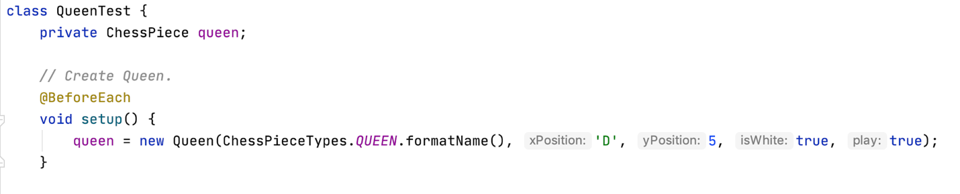

Junit 4:

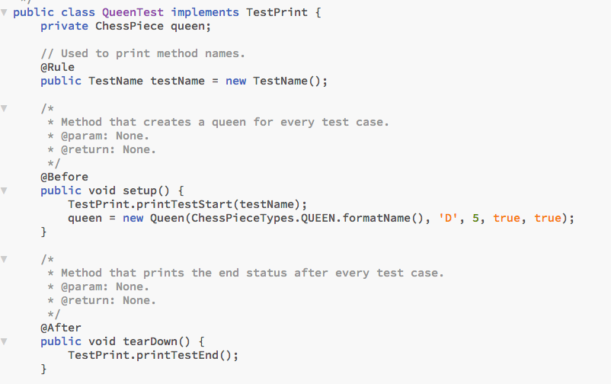

Test Case 1: validMoveDiagonal

The strategy that I selected for this test case was to ensure that the Queen was able to move diagonally and in all four directions: up and to the left, up and to the right, down and to the left, down and to the right. I also wanted to ensure that the queen could move diagonally regardless of the piece color. The validMove method only validates the move. Since I used the template method, the actual method that moves the queen is in the ChessPiece class. However, since the requirements clearly specified that I should only test the queen’s move, I am only testing the validMove method rather than the template method. The reason why I chose this test case was because the diagonal move is one of the three moves that the Queen can perform. Thus, it is crucial to identify if the queen could move diagonally in all directions regardless of whether the piece color is white or black.

Junit 5:

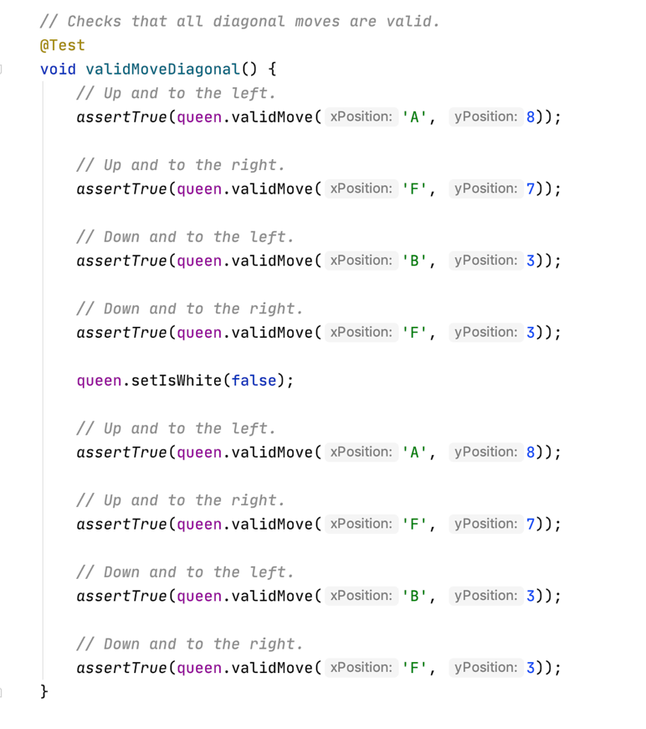

Junit 4:

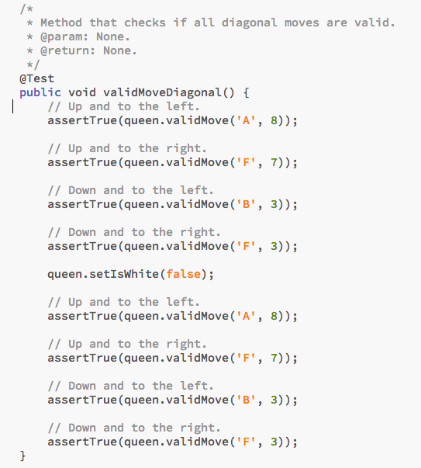

Test Case 2: validMoveHorizontal

The strategy that I selected for this test case was to identify if the Queen could move horizontally. Thus, I decided to have the queen move to the left and to the right. I also changed the queens color and performed the same tests in order to demonstrate that the Queen should be able to remove regardless of the piece color. I selected this test case because the horizontal move is one of the three moves that the queen can perform. I also chose this test case to demonstrate that the amount of squares that the queen moves left or right does not matter.

Junit 5:

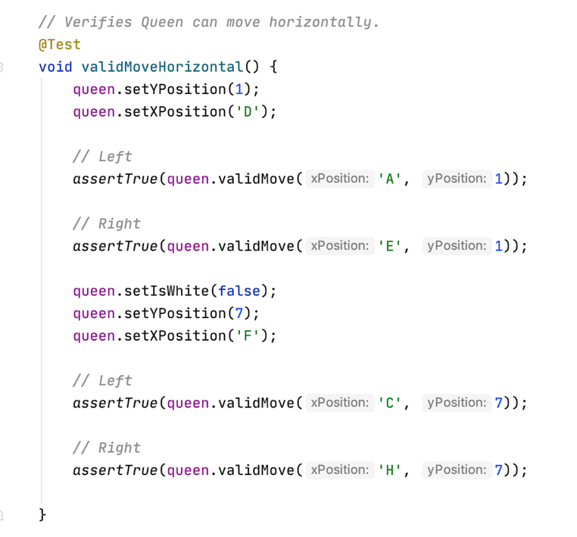

Junit 4:

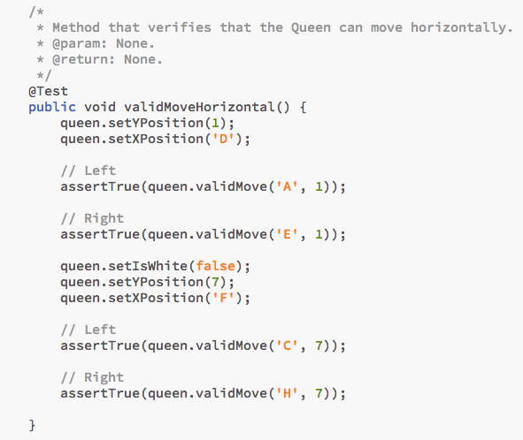

Test Case 3: validMoveVertical

The strategy that I selected for this test case was to identify if the Queen could move vertically. I moved the queen both up and down. I also changed the Queen’s color to black and performed the same tests by moving the queen up and down. I selected this test case because the vertical move is one of the three moves that the queen can perform. Additionally, I wanted to demonstrate that the Queen could move vertically regardless of her position on the chess board. For the white queen version, I positioned her near the middle of the board and for the black queen, I positioned her near the left corner of the board.

Junit 5:

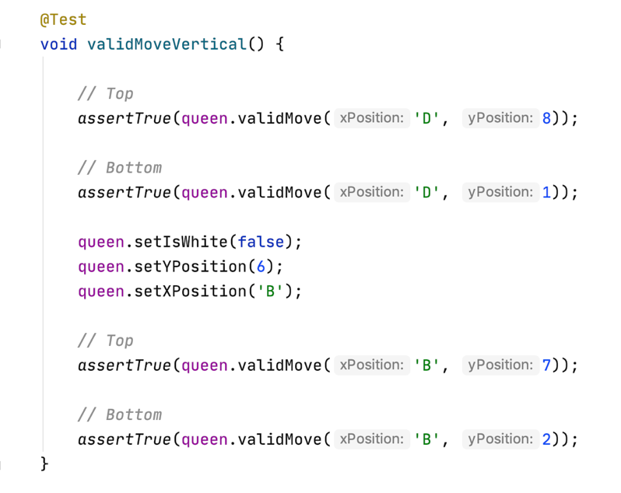

Junit 4:

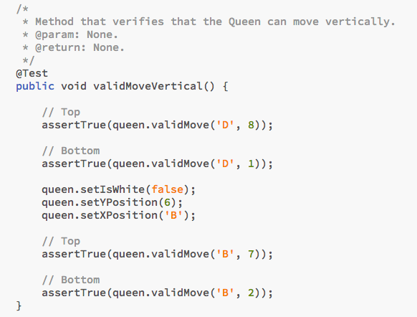

Test Case 4: invalidMoveLShape

The strategy that I selected for this test case was to ensure that the Queen could not move in an L shape like the knight. The L shape is the only move that the queen cannot perform, so I thought that it was essential to test that she could not perform this move. To carry out this test I moved the queen to four different L shape positions: top right, top left, bottom right, and bottom left. I thought that it was important to test the L shape in all four different directions. This was to ensure that the queen was not inheriting moves form the Knight.

Junit 5:

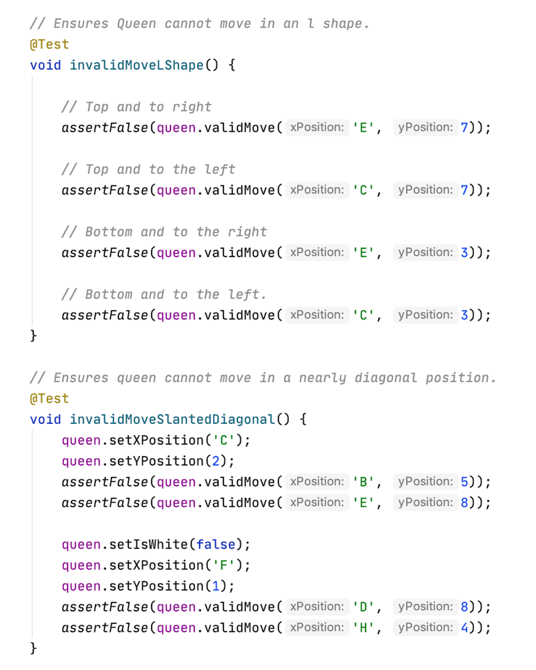

Junit 4:

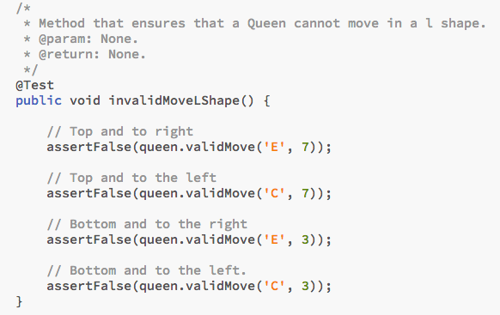

Test Case 5: invalidMoveSlantedDiagonal

The strategy that I selected for this test case was to ensure that the Queen could not move to a position that was nearly diagonal. Thus, I selected positions that were one above the correct diagonal square. I also selected positions that were one away from a horizontal line but far away from the diagonal line. I selected this test case to ensure that the horizontal and diagonal moves remained distance. I wanted to ensure that nearly diagonal positions could not be reached by the queen.

Junit 5:



Junit 4:

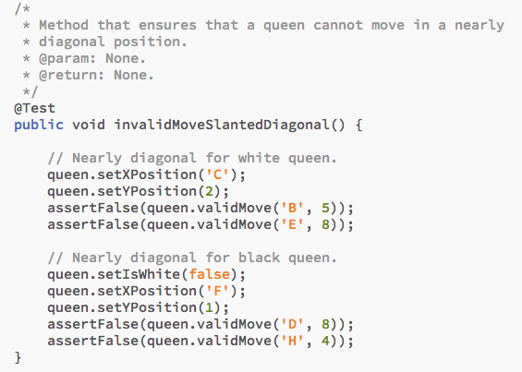

Test Case 6: outOfBoundsXPosition

The strategy that I selected for this test case was to ensure that the user could not

enter invalid x positions for the queen to move to. The way that I tested this portion was by using the gameView’s selectX method which collects the x position for the valid move. In order to test this, I fed a string of values into the scanner to replicate a user’s input. I included numbers as well as letters that were not included on the board. I finally included an “a” at the end of the string so the program could eventually collect the correct x position. I thought that this test case was important to ensure that the Queen will never be able to move to an invalid position. The selectX method will always ensure that a correct x value is selected before moving on.

Junit 5:

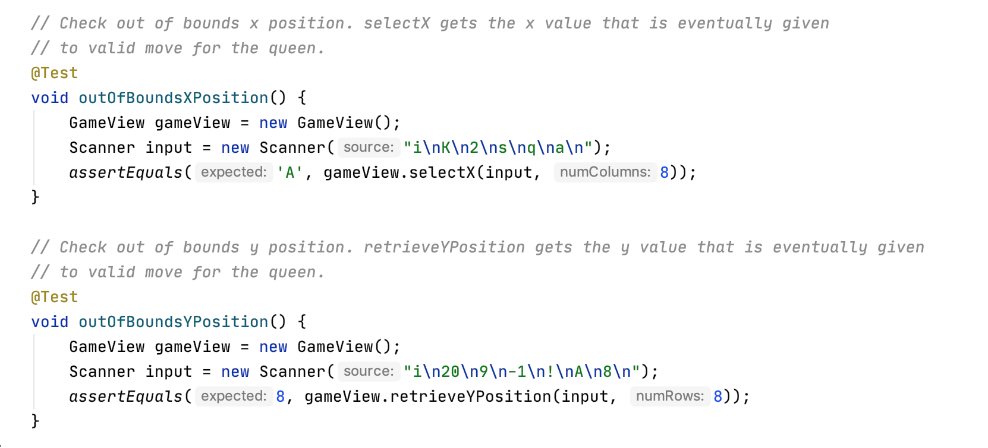

Junit 4:

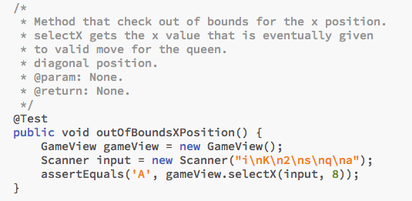

Test Case 7: outOfBoundsYPosition

The strategy that I selected for this test case was to ensure that the user could not enter invalid y positions for the queen to move to. I tested this portion by using the gameView’s retrieveYPosition method which collects the y position for the valid move. For the scanner string, I included letters, symbols, and number other than 1 - 8. I finally included an “8” at the end of the string so the program could eventually collect the correct y position. I thought that this test case was important to ensure that the Queen will never be able to move to an invalid y position. The retrieveYPosition method will always ensure that a correct y value is selected before moving on.

Junit 5:



Junit 4:

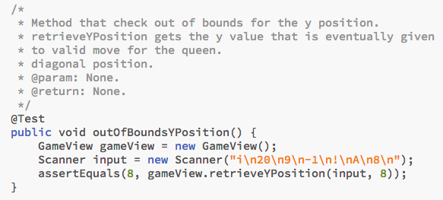

Queen Test Results

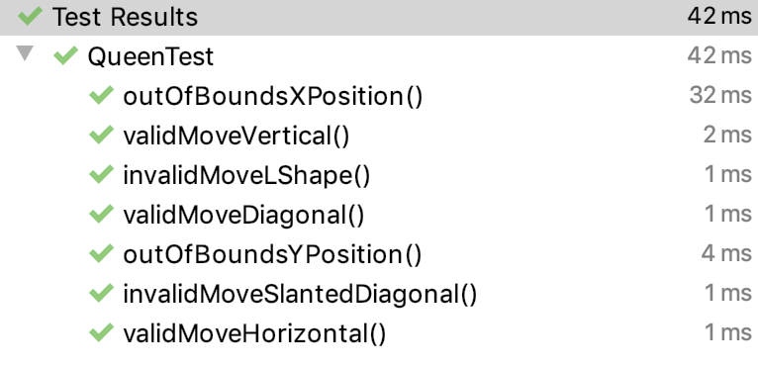

## Method 2 – pickGameToLoad(Scanner input) from GameSelector

I selected the pickGameToLoad method due to its use of both array lists and queues. For this method I pop the three last elements in the deque while simultaneously adding them to the array list. I allow the game that they want to load which corresponds to an index on the array list. Then in order to preserve the order of the games, I put the games back at the tail of the queue from the end of the list to the top of the list. However, if the game was the one that the user selected, I insert it at the end. As you can see, this process, while not difficult, is very prone to bugs. In fact, while designing my tests, I actually found some bugs through my test cases. For brief notation, I will be describing the deque as [head, …., tail] for the rest of the test cases. The tail will always have the most recent game. At most three elements will be removed from the tail of the deque to the array list. I will also use letters to denote the string of ids stored. For a quick diagram of the overall process, imagine if I have a deque as [C, B, A]. A is the newest game and C is the oldest game. The deque is then fed into an array as {A, B, C} and printed to the user as Select: 1.A, 2.B, and 3.C. The user makes their selection, let’s say 3. Then the array list is put back into the deque as [B, A] and then the user selected element is added at the tail of the deque. Thus, our final deque would be [B, A, C].

All test cases start with:

Junit 5:

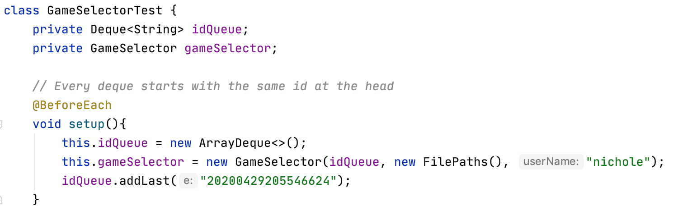

Junit 4:

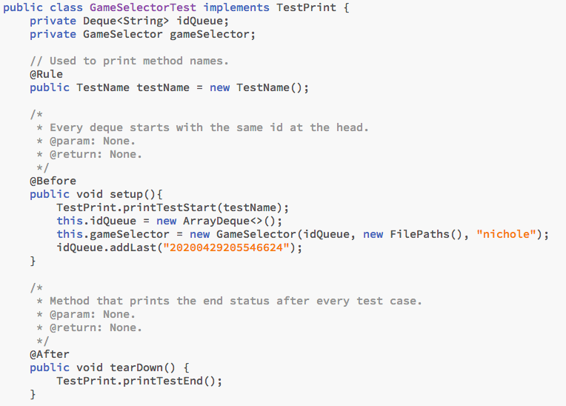

Note: Test Cases 1, 2, and Extra – pickToLoadCenterElement are all members of class GameSelectorNestedTest

Junit 5:

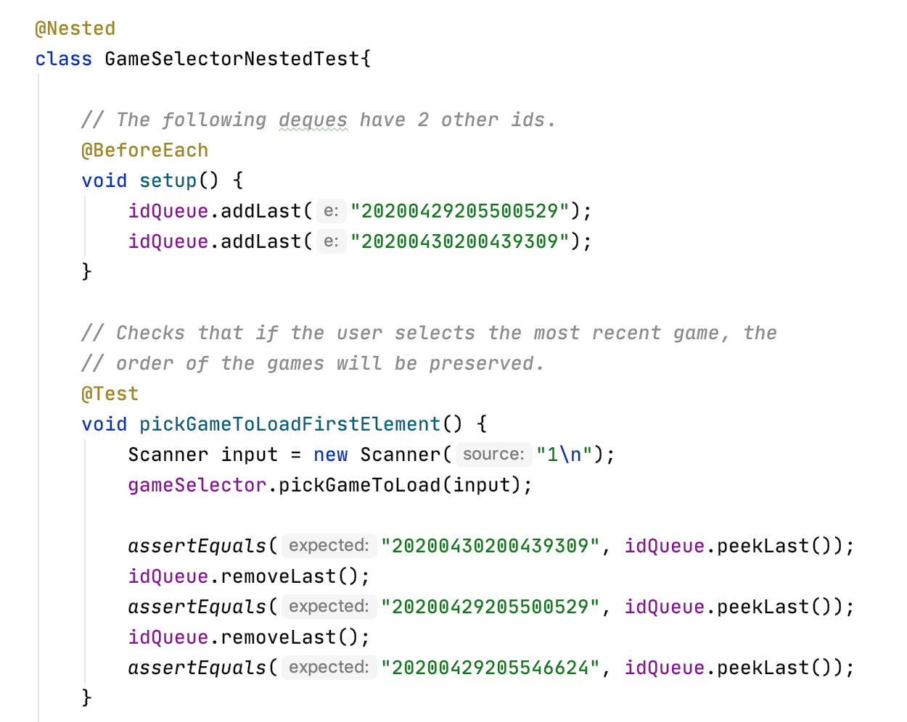

Test Case 1 – pickGameToLoadFirstElement

The strategy that I selected for this test case was if the deque had at least three elements which were pushed onto the array list, and the user selected the most recent game. So, I built the deque as [C, B, A]. I then fed a string to the scanner where the first element, A was selected. This in turn should lead to the array list as {A, B, C}. Then the elements should be put back onto the deque as [C, B, A]. I then tested to ensure that this was the correct arrangement of the elements on the deque. I selected this test case since it describes the most basic scenario where the user selects the most recent game.

Junit 5:



Junit 4:

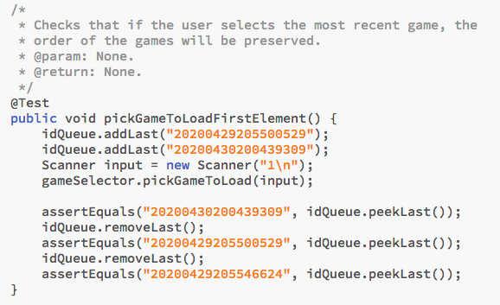

Test Case 2 – pickGameToLoadLastElement

The strategy that I selected for this test case was if the deque had at least three elements and the user selected the oldest game. So, I built the deque as [C, B, A]. I then fed a string to the scanner where the third element, C, was selected. This in turn should lead to the array list as {A, B, C}. Then the elements should be put back onto the deque as [B, A, C]. I then tested to ensure that this was the correct arrangement of the elements on the deque. I selected this test case since it describes a common route that the user could select. However, it is not as basic and is crucial to ensure that the deque elements keep their order.

Junit 5:

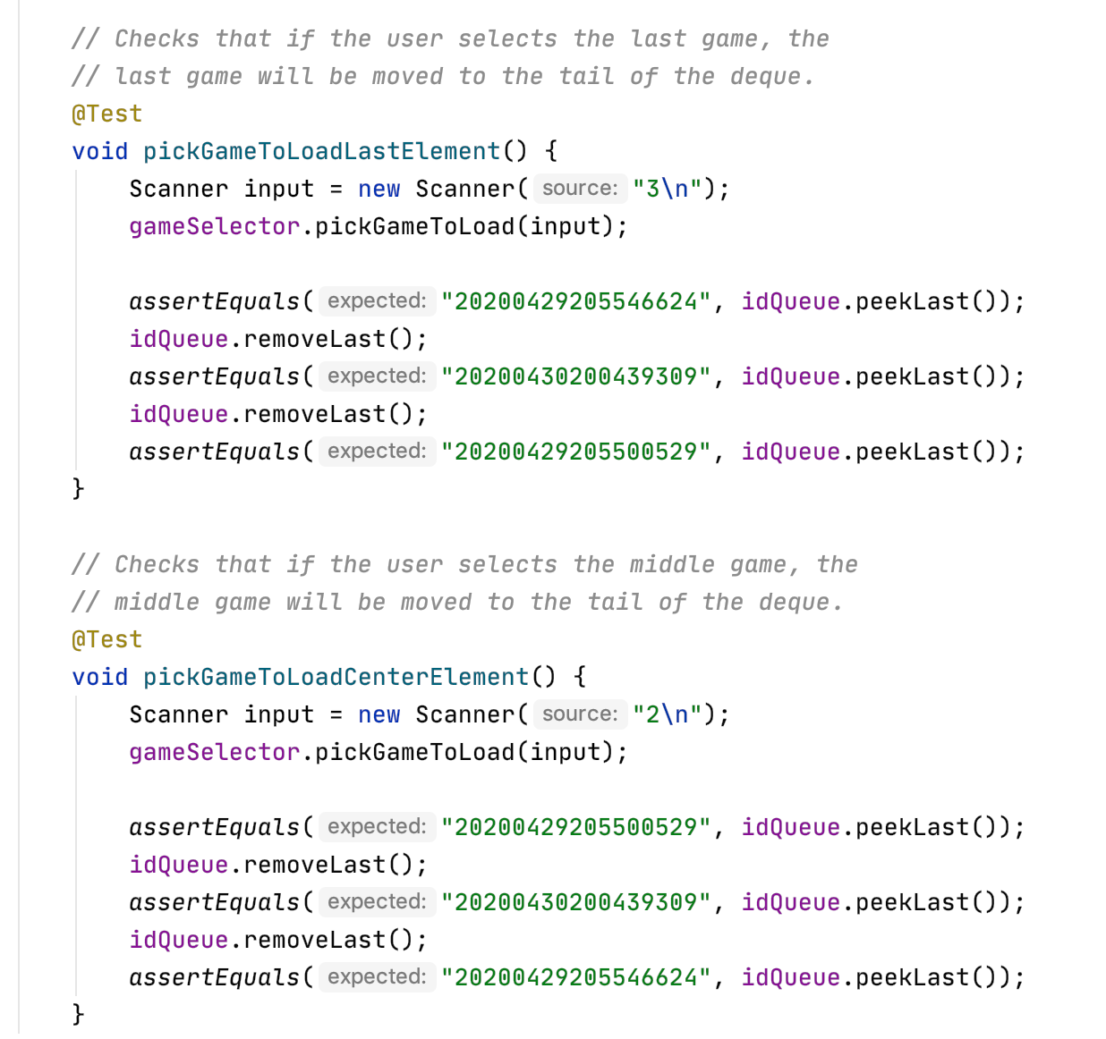

Junit 4:

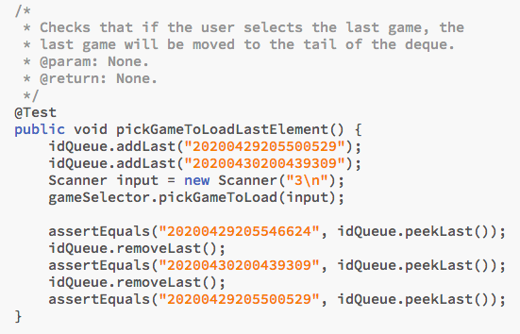

Test Case 3 – pickGameToLoadInvalidId

The strategy that I selected for this test case was that if the deque contained an invalid id, the program would remove it from the queue but not count it as an option to load. So, I built the deque as [C, invalidId, A]. I then fed a string to the scanner where the second element, C, was selected. This in turn should lead to the array list as {A, C}. Then the elements were put back onto the deque as [A, C]. I then tested to ensure that this was the correct arrangement of the elements on the deque. I also tested the size of the array list to see if it only contained 2 elements, demonstrating that the invalidId was deleted. I selected this test case because tampering an XML file could lead to an invalid id. The method calls a timestamp to readable date convert, which throws a parser error if the date cannot be parsed. Thus, I wanted to test the edge case of what would occur if an invalid id did exist.

Junit 5:

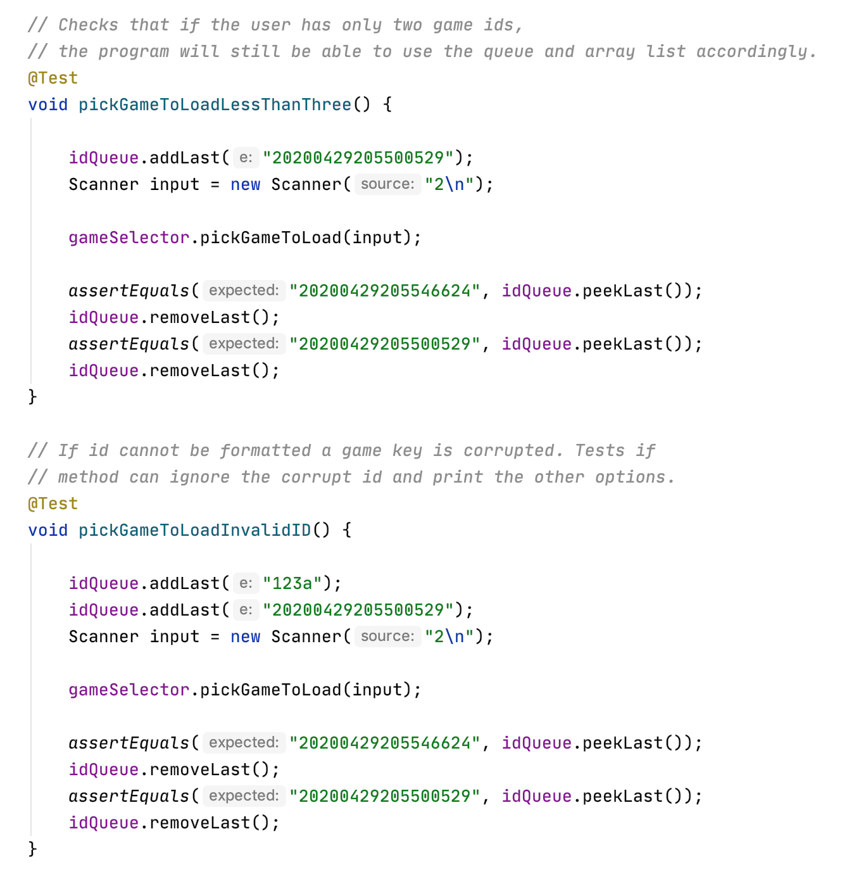

Junit 4:

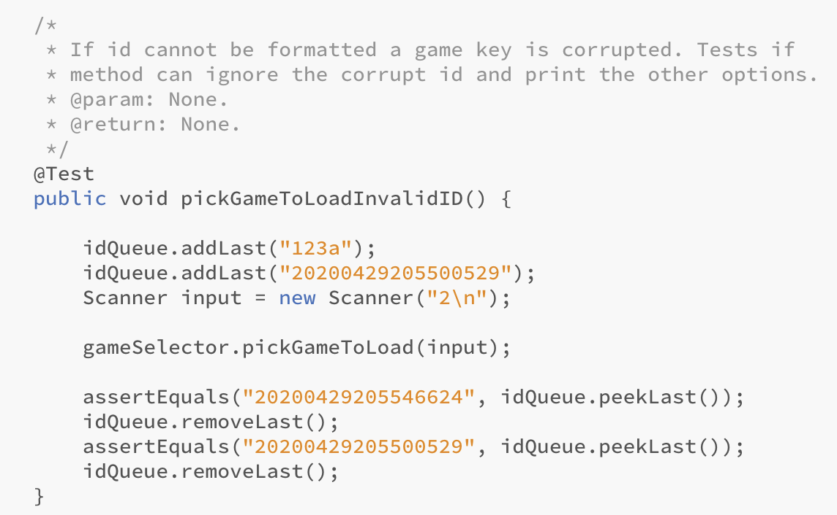

Test Case 4 – pickGameToLoadInvalidSelection

The strategy that I selected for this test case was if the user selected an invalid game number to load. If the user does select an invalid game number, the program loads the most recent game. In order to carry out this test case, I built the deque as [B, A]. I then fed a string to the scanner where a nonexistent third element was selected. This in turn should lead to the array list as {A, B}. Then the elements were put back onto the deque as [B, A]. I then tested to ensure that this was the correct arrangement of the elements on the deque. It was crucial that A was at the tail of the deque since this denotes the game that will be loaded. I selected this test case because it is very probable that a user will select an invalid game number. I was going to continue to ask the user for a selection number but decided that users will most likely want to play their most recent game.

Junit 5:

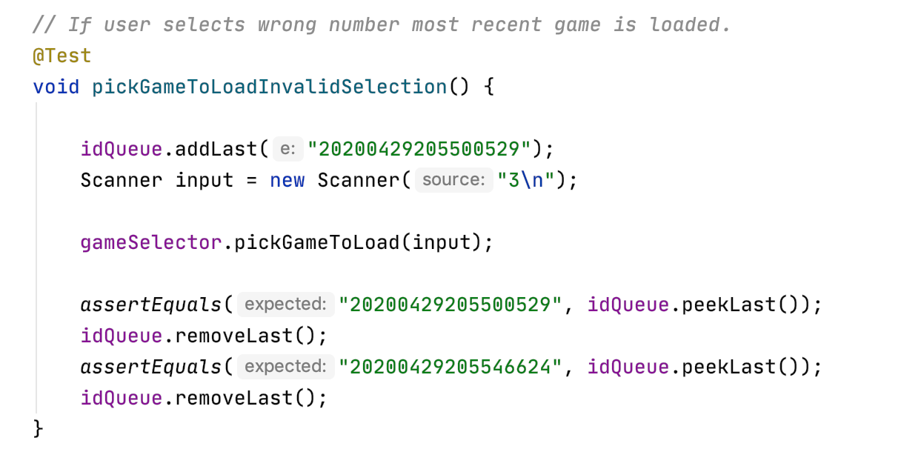

Junit 4:

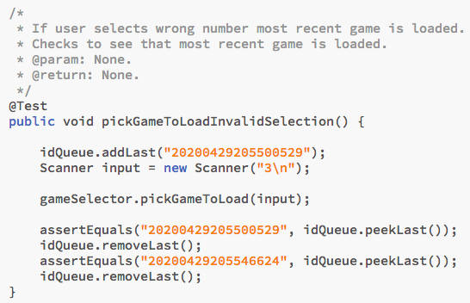

Extra Test Cases - I also made test cases for a user selecting the middle element and a user selecting from a queue with less than three elements to ensure that size would not affect the programs functionality. They can be seen below.

Junit 5:





Junit 5:

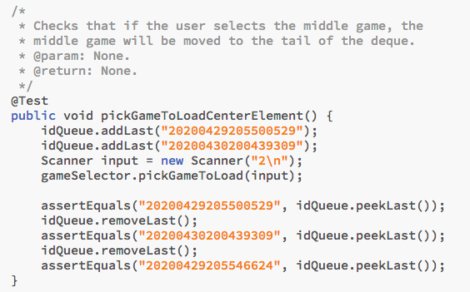

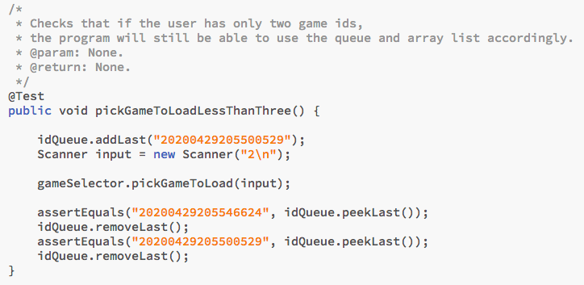

GameSelector Test Results

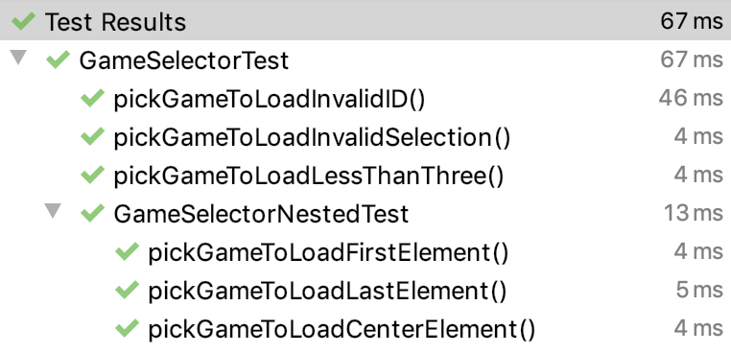

## Method 3 – arrangePassword(PasswordManager passwordManager, Element user, Scanner input) from UserCreator

I selected arrangePassword from UserCreator, not necessarily due to complex logic like the previous example but do complex branching of instructions. The arrangePassword method gets a PasswordManager and a user element. If the user element has a password element with a non-null password of at least one character, then a verification process is performed to make sure that the user can correctly enter their password. If the user fails to do so five times, then the user is logged out. If the password is null or has zero characters, then the Password manager asks the user to enter a new password. The Password manager will strip the password of all white space and store it. The arrangePassword function is then responsible for creating a 2 element Boolean array and returning it. The first Boolean denotes whether or not a new password was created and consequently elements were added to the user. The second Boolean denotes whether the password was valid. As you can see, although none of these methods are particularly difficult to code, the arrangePassword functions almost as a mini controller among several events. I therefore wanted to ensure that all these events were behaving accordingly.

All test cases start with:

Junit 5:

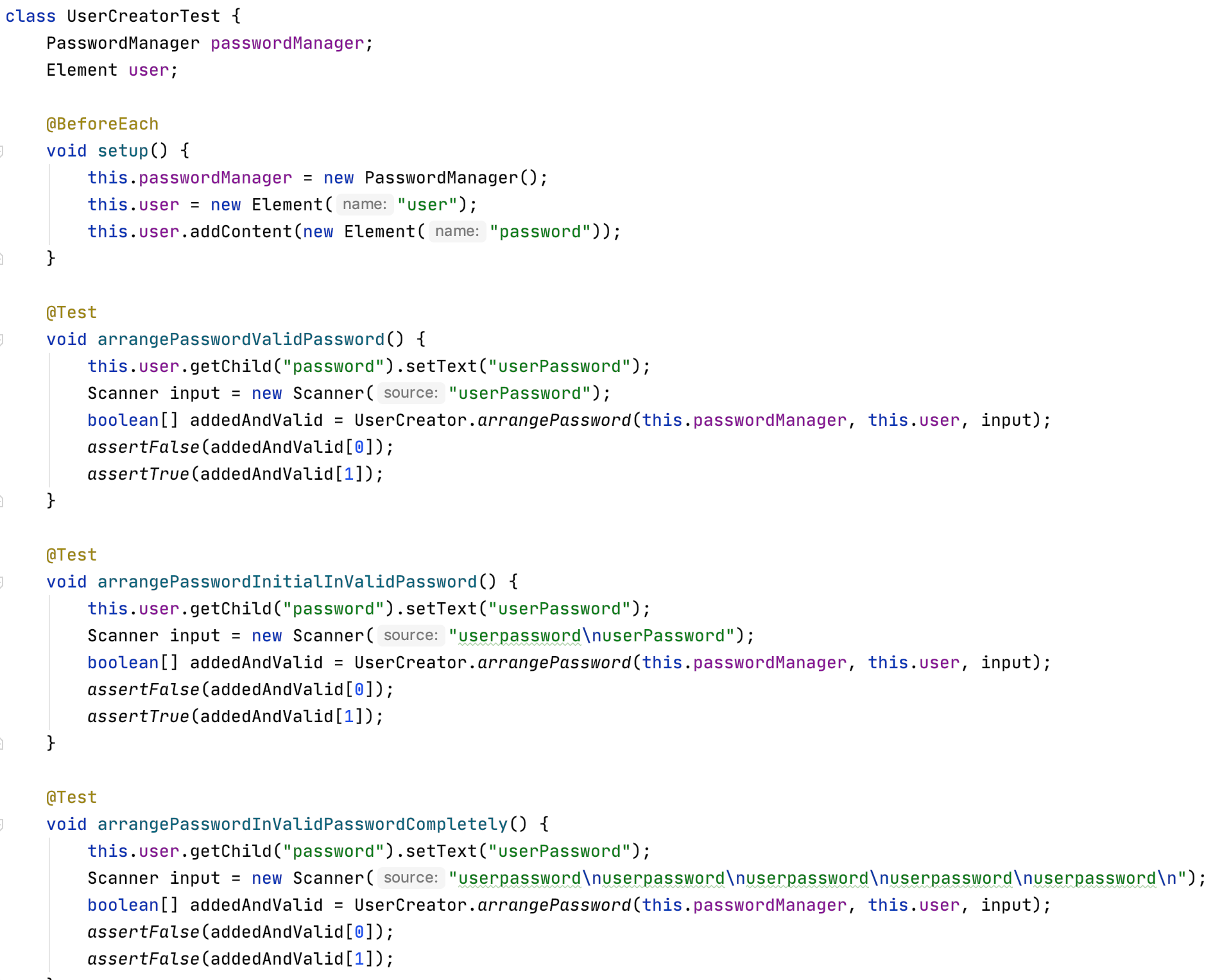

Junit 4:

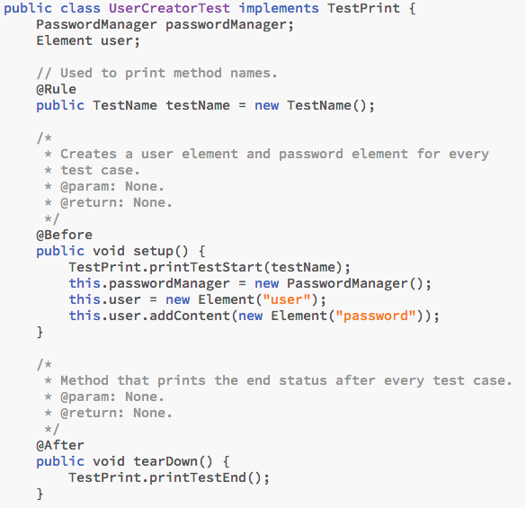

Test Case 1 – arrangePasswordValidPassword

The strategy that I selected for this test case was if the user element contained a password element with password text. I then fed a string into the scanner with the correct text to match the password. After calling the method, I checked to make sure that the added value was false and the valid Boolean was true. I selected this test case to test the most basic functionality of the method. This test case tests the base case scenario in which the user is able to accurately type their password.

Junit 5:



Junit 4:

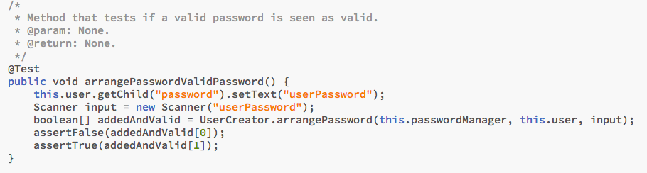

Test Case 2 - arrangePasswordInValidPassword and arrangePasswordInValidPasswordCompletely

For this test case, I created two different sub test cases. The first test case tests if the user enters their password wrong on the first time but correct on the second time. The second sub test case tests if the user incorrectly types their password each time. The strategy that I selected for the first sub test case was to pass a string with an invalid password and then the correct password afterwards. I then checked to make sure that the element added Boolean was false and the valid Boolean was true. For the second sub test case, the strategy I selected was to create a string of 5 incorrect passwords that the scanner read. The program is supposed to time out at 5 and consequently quit. After calling the method, I checked to make sure that the added Boolean was false and the valid Boolean was also false. I selected these test cases because they test a common behavior that could occur. People often forget their passwords, so I wanted to make sure that my program could handle invalid passwords.

Junit 5:

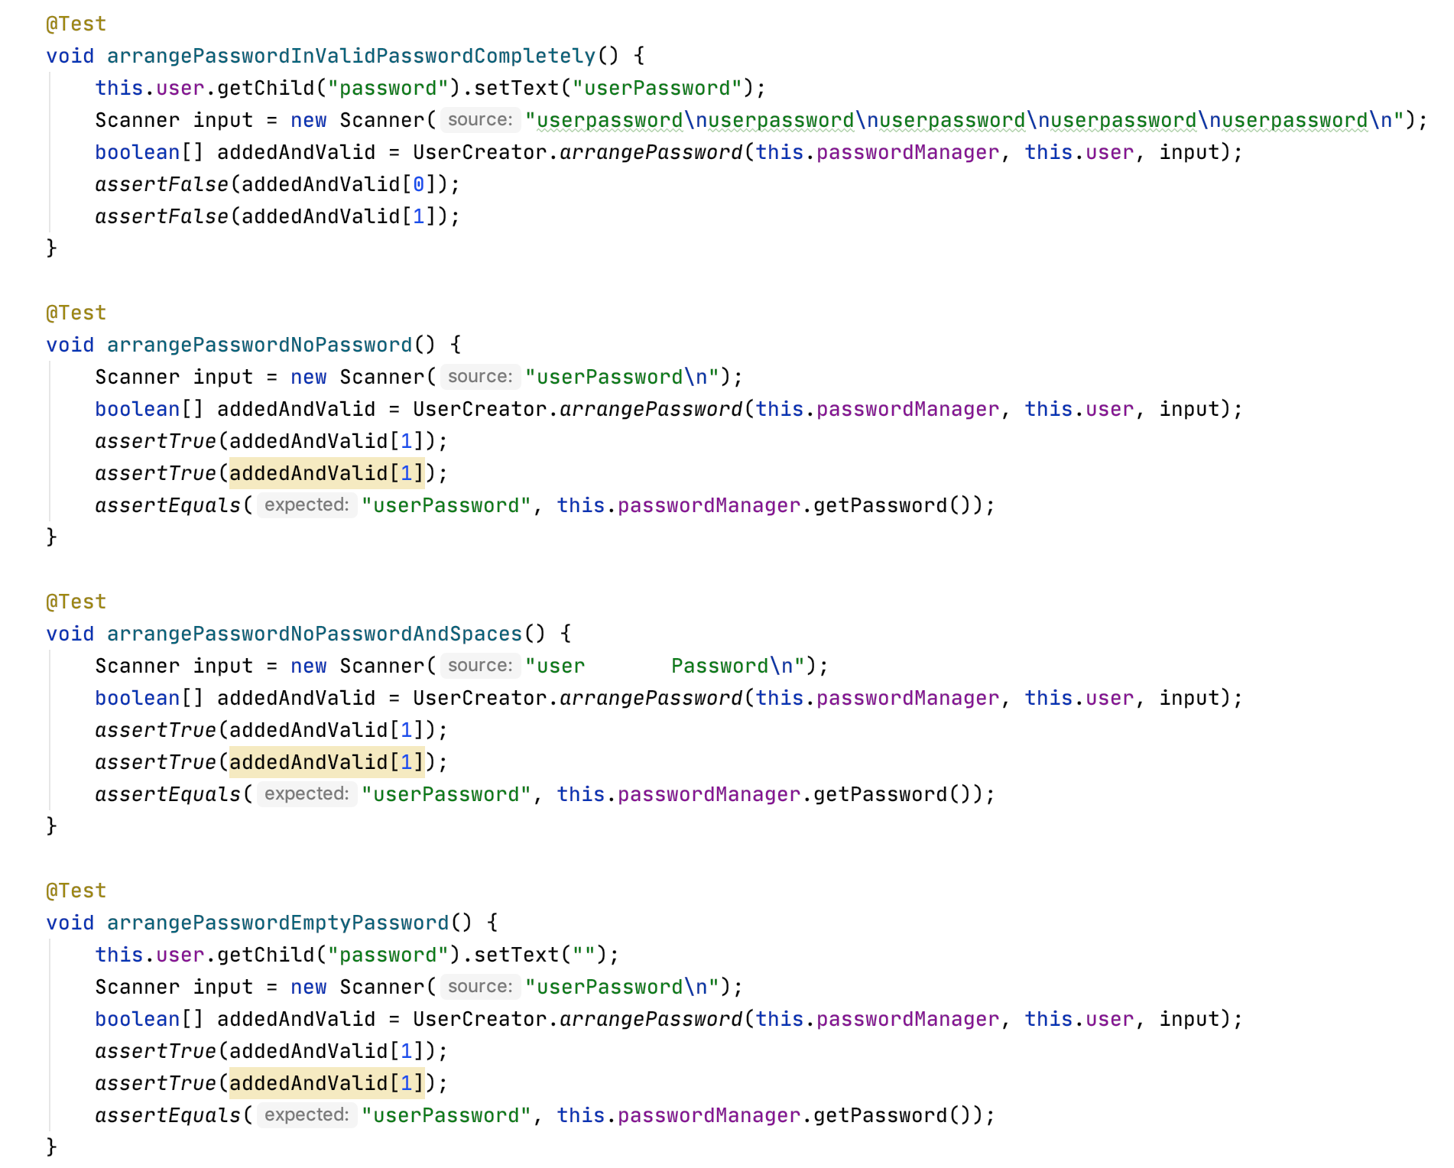

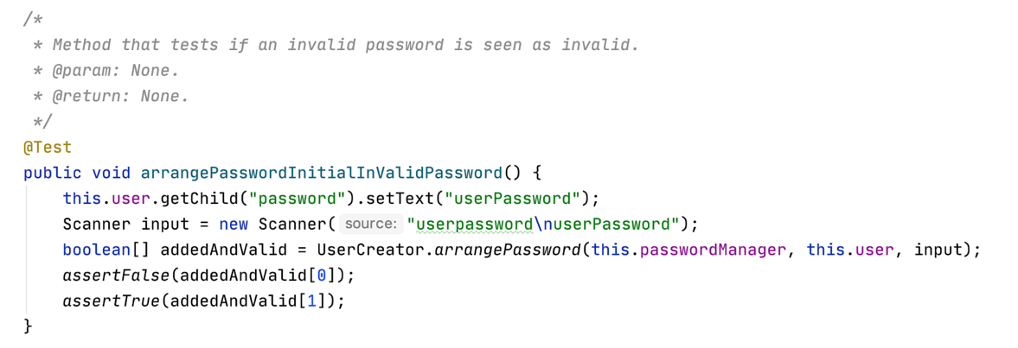

Junit 4:

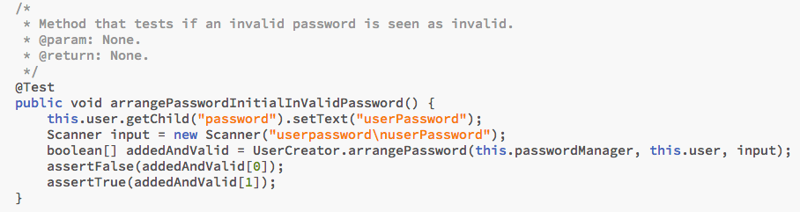

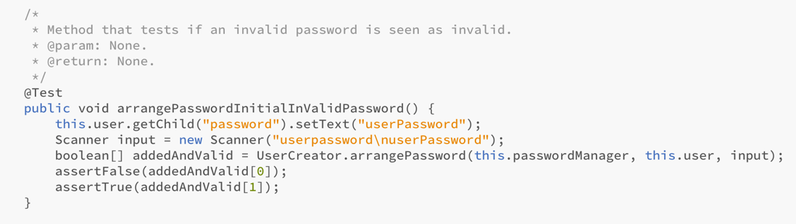

Test Case 3 – arrangePasswordNoPassword

The strategy that I selected for this test case was if the XML file for some reason did not contain a password element for the user. Therefore, I did not add the password to the user element and called the method. I fed in a string to the scanner with the new password. At the end of the test, I made sure that the added and valid Boolean were both true. I also checked that the password the PasswordManager had saved matched the password entered from the string. I selected this strategy since the XML are easily able to be modified. This means that someone could go into an XML file and delete a password. In which case, I want to ensure that my program will not crash but rather allow the user to select a new password.

Junit 5:



Junit 4:

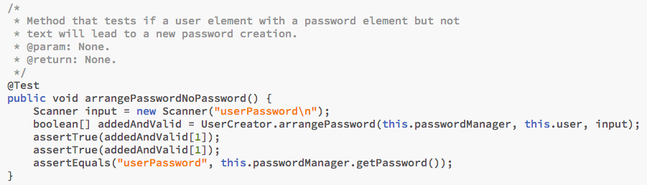

Test Case 4 – arrangePasswordEmptyPassword

The strategy that I selected for this test case was if the user element had a password element, but the element did not have any text. Therefore, I created the user and the password element, but never set the text. I called the method and fed in a string to the scanner with the new password. At the end of the test, I made sure that the added and valid Boolean were both true. I also checked that the PasswordManager had, yet again, saved the password entered from the string. I selected this strategy because I realized that someone could easily delete their password from the XML file, but not the tag. I do not want to create a player with an empty password, so it is necessary to have a check routine that ensures that all players have created a password with at least one character.

Junit 5:



Junit 4:

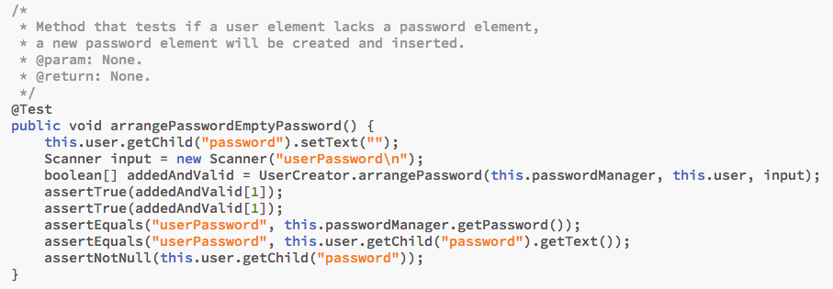

Extra Test Case – I also created a test case that ensures that a password is stripped of all whitespace and store when a user enters a new password. This can be found below.

Junit 5:



Junit 4:

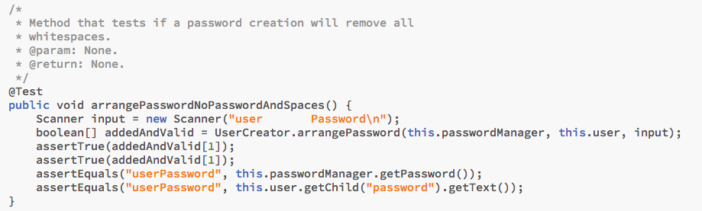

UserCreator Test Results

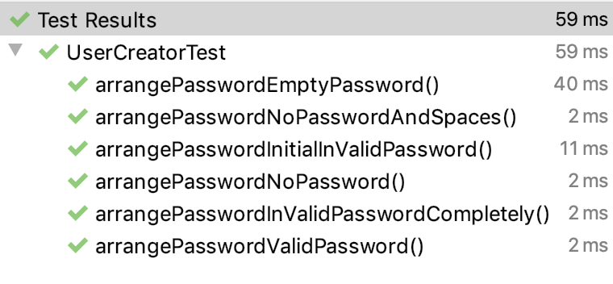

# Extra Unit Test Code

Since I did not originally know how many test cases were needed, I created two extra ones for GameDeleter and GameModel. The GameDeleter checks the deleteUserSelectedGames to ensure that the games that the user chooses to delete are removed from the deque. The GameModel checks the verifyAndInitiateMove method which is used to move the piece based on the user’s input. The tests for each one can be found below.

GameDeleter Unit Test Cases

Junit 5:

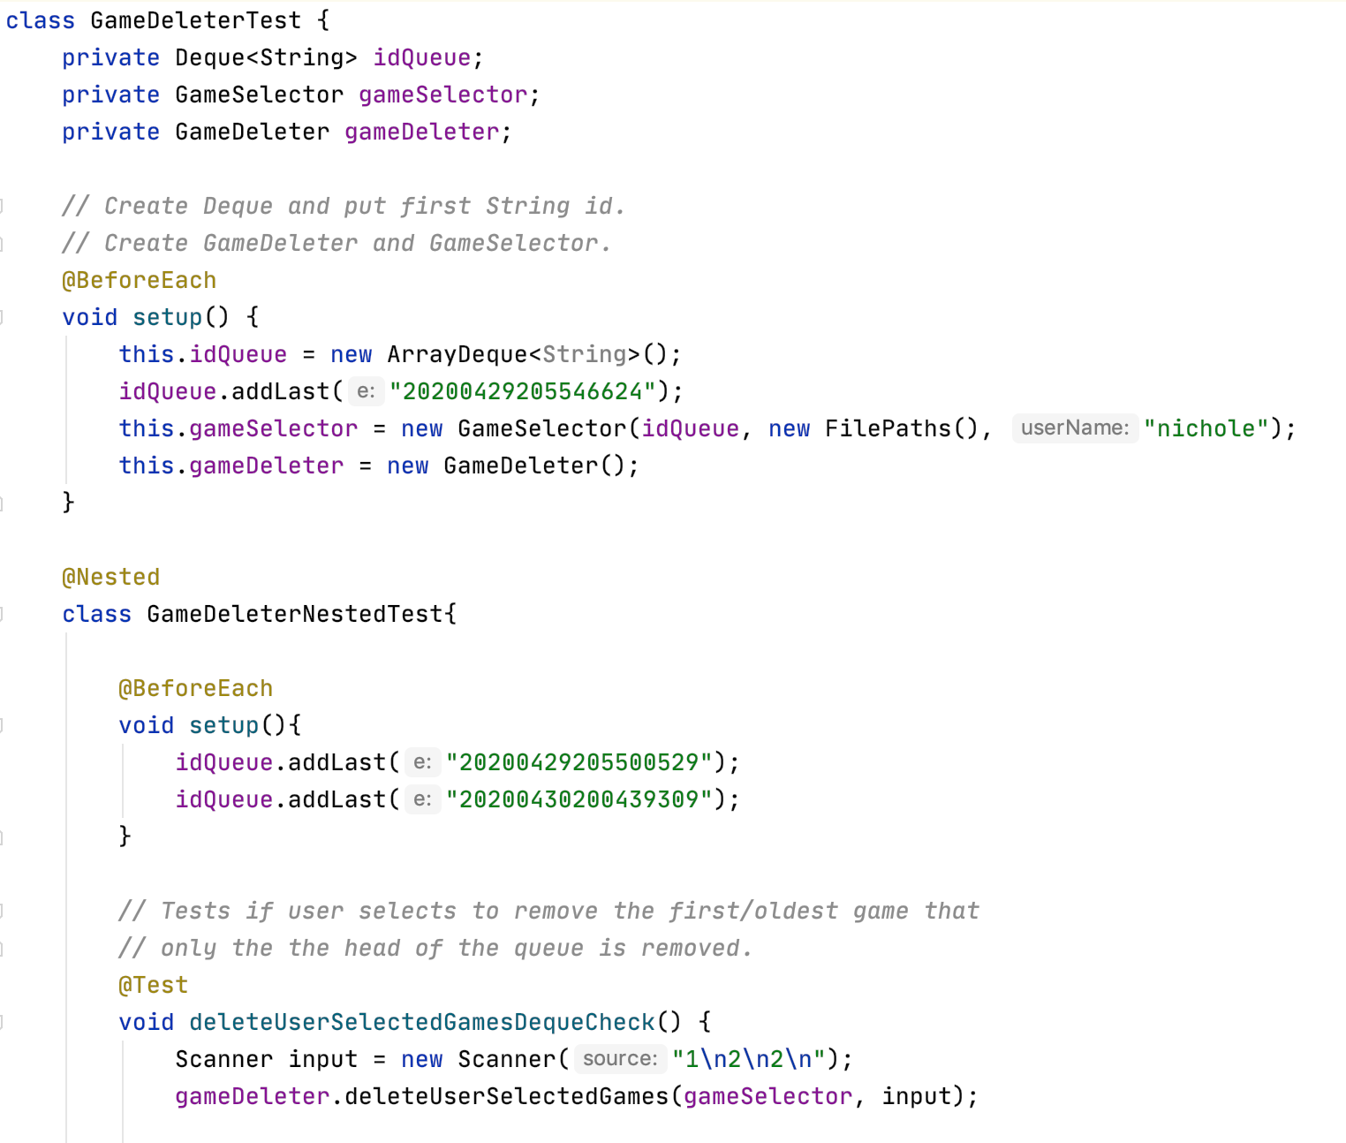

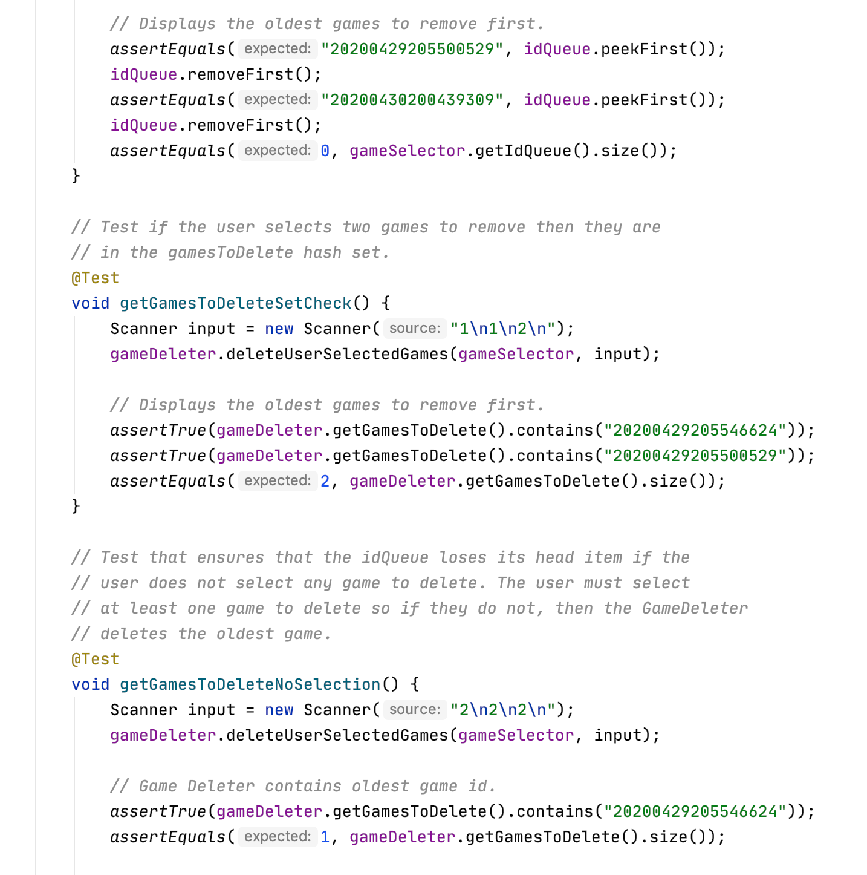



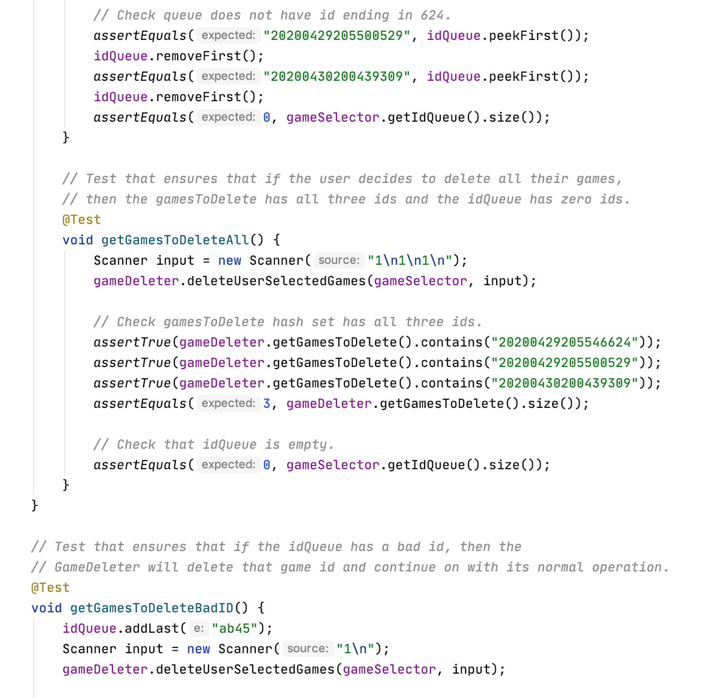



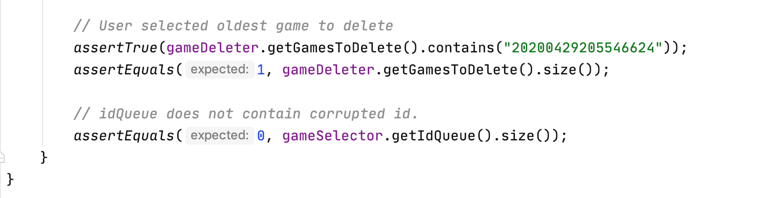

Junit 4:

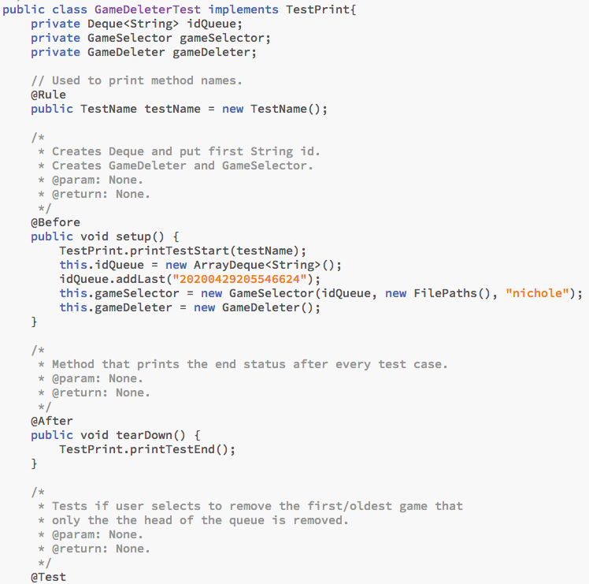



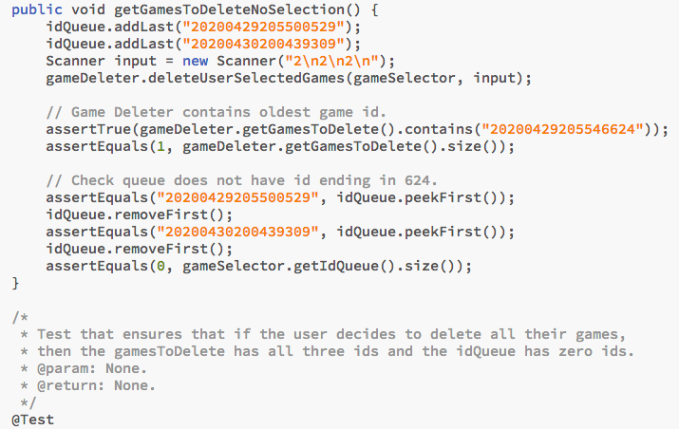

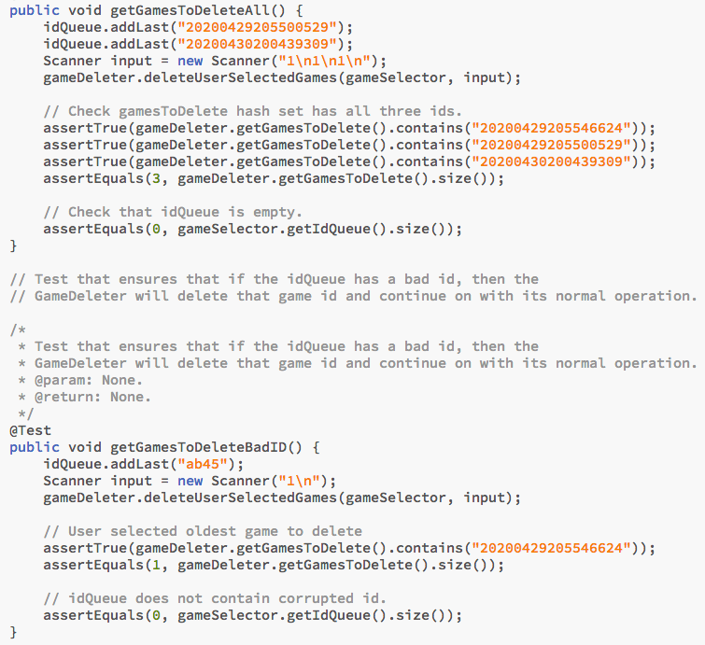

GameDeleter Test Results

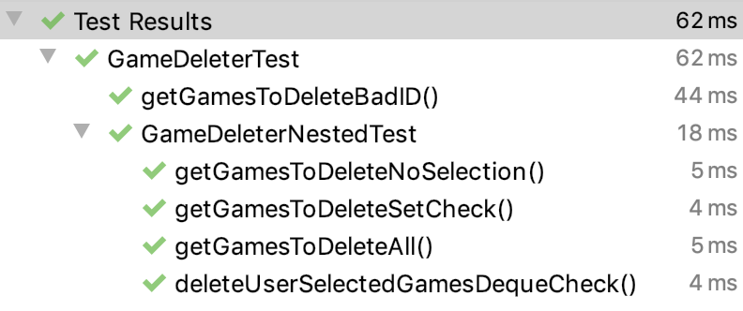

GameModel Unit Test Cases

NOTE: These tests are crucial to see how the all the chess pieces move throughout the board. This test case best demonstrates the move functionality and the complex logic between the Game, GameModel, and GameView. Since we were only supposed to have the Queen Move as a unit test, I have decided to list these extra tests to demonstrate the entirety of not only validating a move but actually moving a piece.

Junit 5:

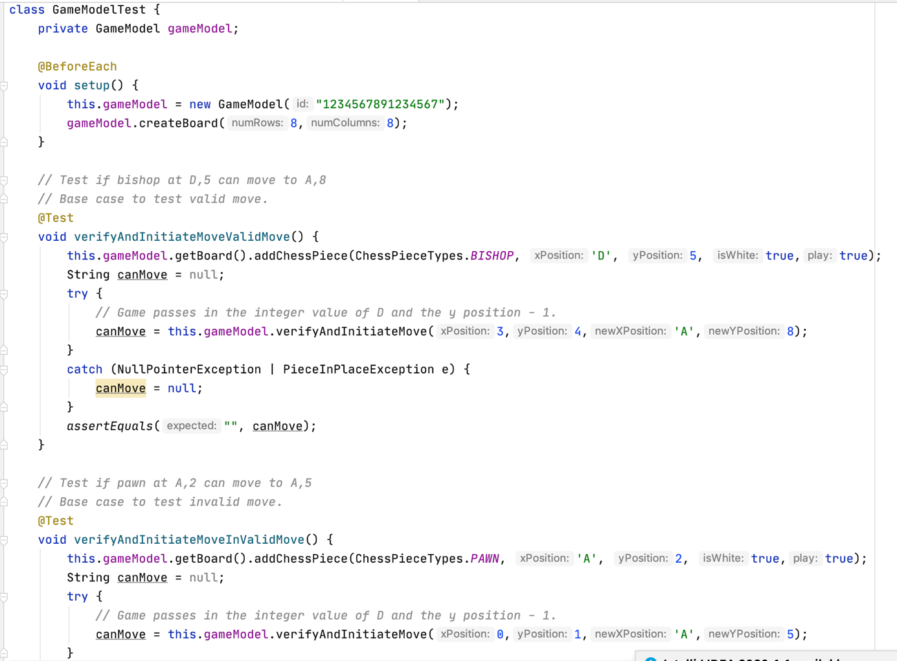

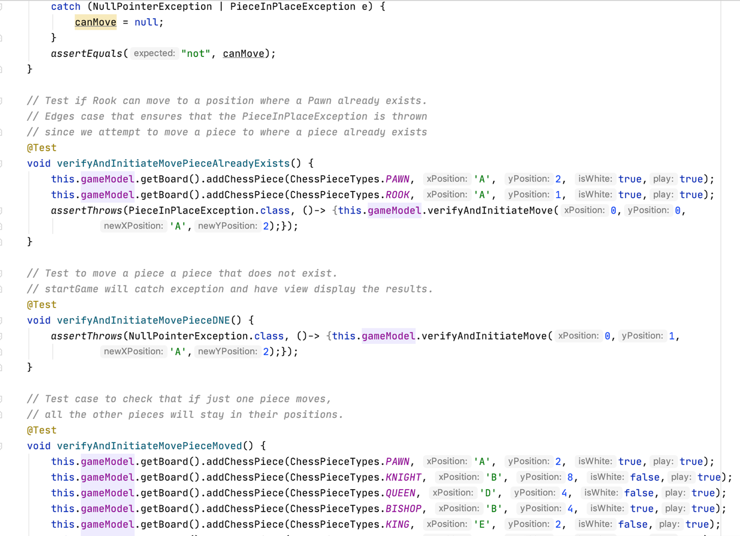

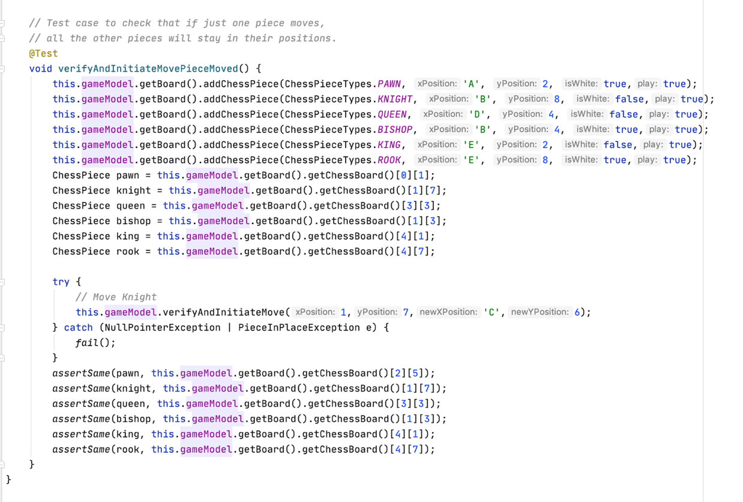

Junit 4:

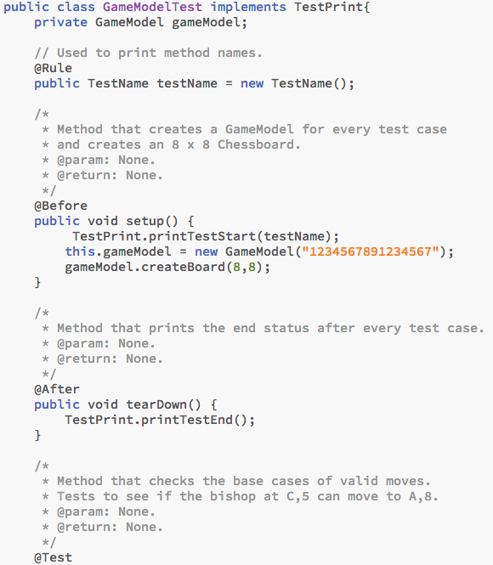

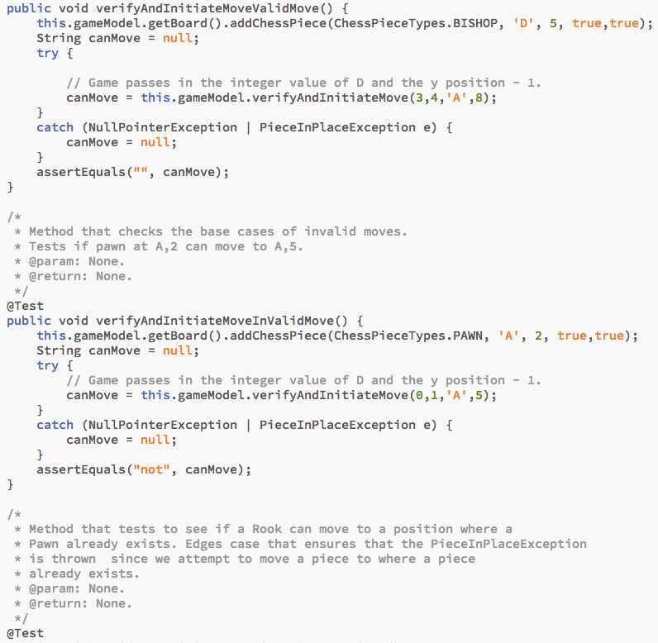

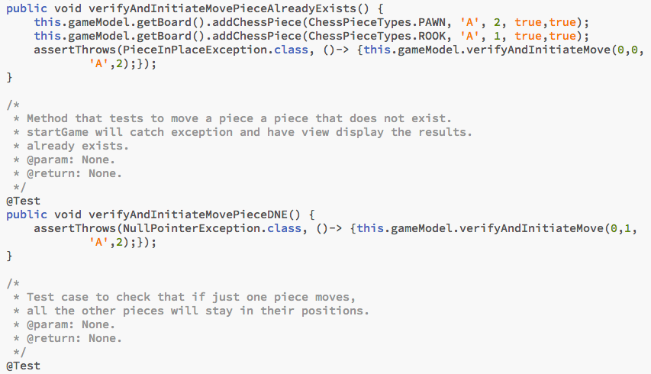

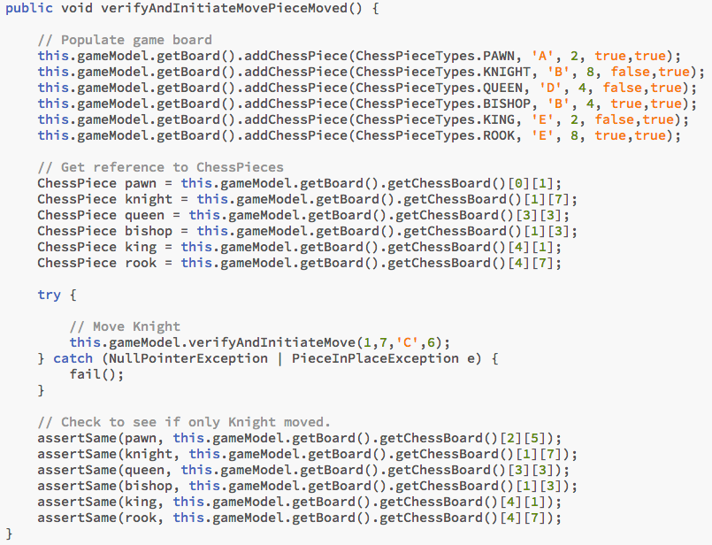

GameModel Test Results

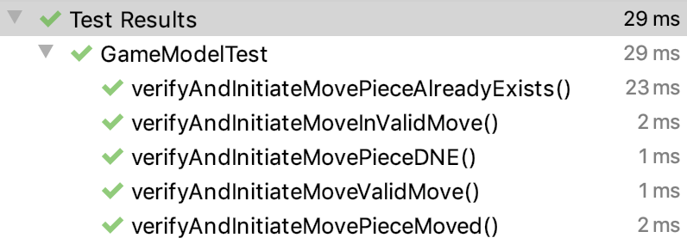

Code Functionality

A brief overview of my program is as follows. The Controller is first created and the main program calls its runChessInterface method. From the runChessInterface method, the Controller creates a Parser which collects the necessary FilePaths. As explained above, these file paths are hashed based on the file types. Then the Parser creates a ParserReader and ParserWriter and passes the file paths to the objects. From there, the Controller has the parser create the player. The parser calls a specific ParserReader function based on whether the user is a new or existing user. If the player is an existing player, then the list of ids is converted to the deque using the stream (see above for more information).

elementsToIds() from ParserReader.java

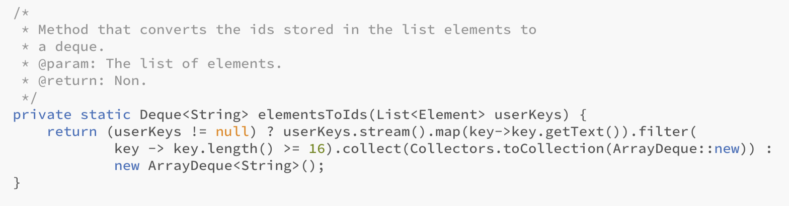

Additionally, when creating a new user, a HashMap of all the passwords and usernames is created. This is used to ensure that all usernames are unique.

userDoesNotExist() from ParserReader.java

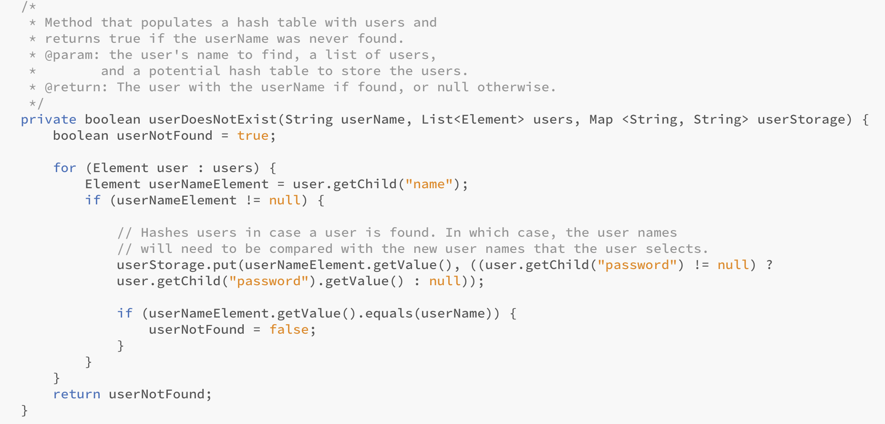

When creating an existing user from file, ParserReader calls retrieveUserByName to retrieve the user element from a list of elements. A stream is used to perform this task. The stream filters the collection to only include elements with a name element. The findFirst method is then applied on the stream and an optional element is returned. An optional element is essentially a container that stores the user element if it was found. If the user element was found, then it is returned, otherwise null is returned.

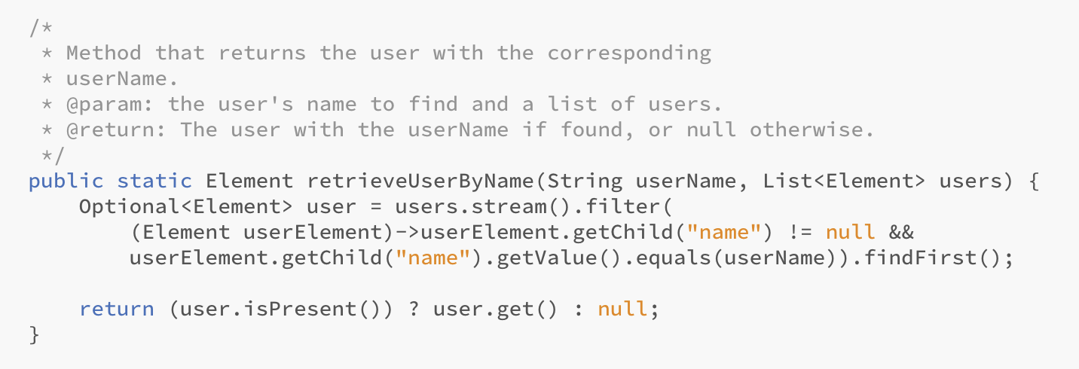

If the user is an existing user, then the PasswordManager verifies that the password from the XML file matches the password entered. The arrangePassword in UserCreator is used to have the PasswordManager enact its duties of verifying the password. If the user is new, then the PasswordManager allows the user to select their own password. The passwords are also stored in the user XML file.

arrangePassword() from UserCreator.java

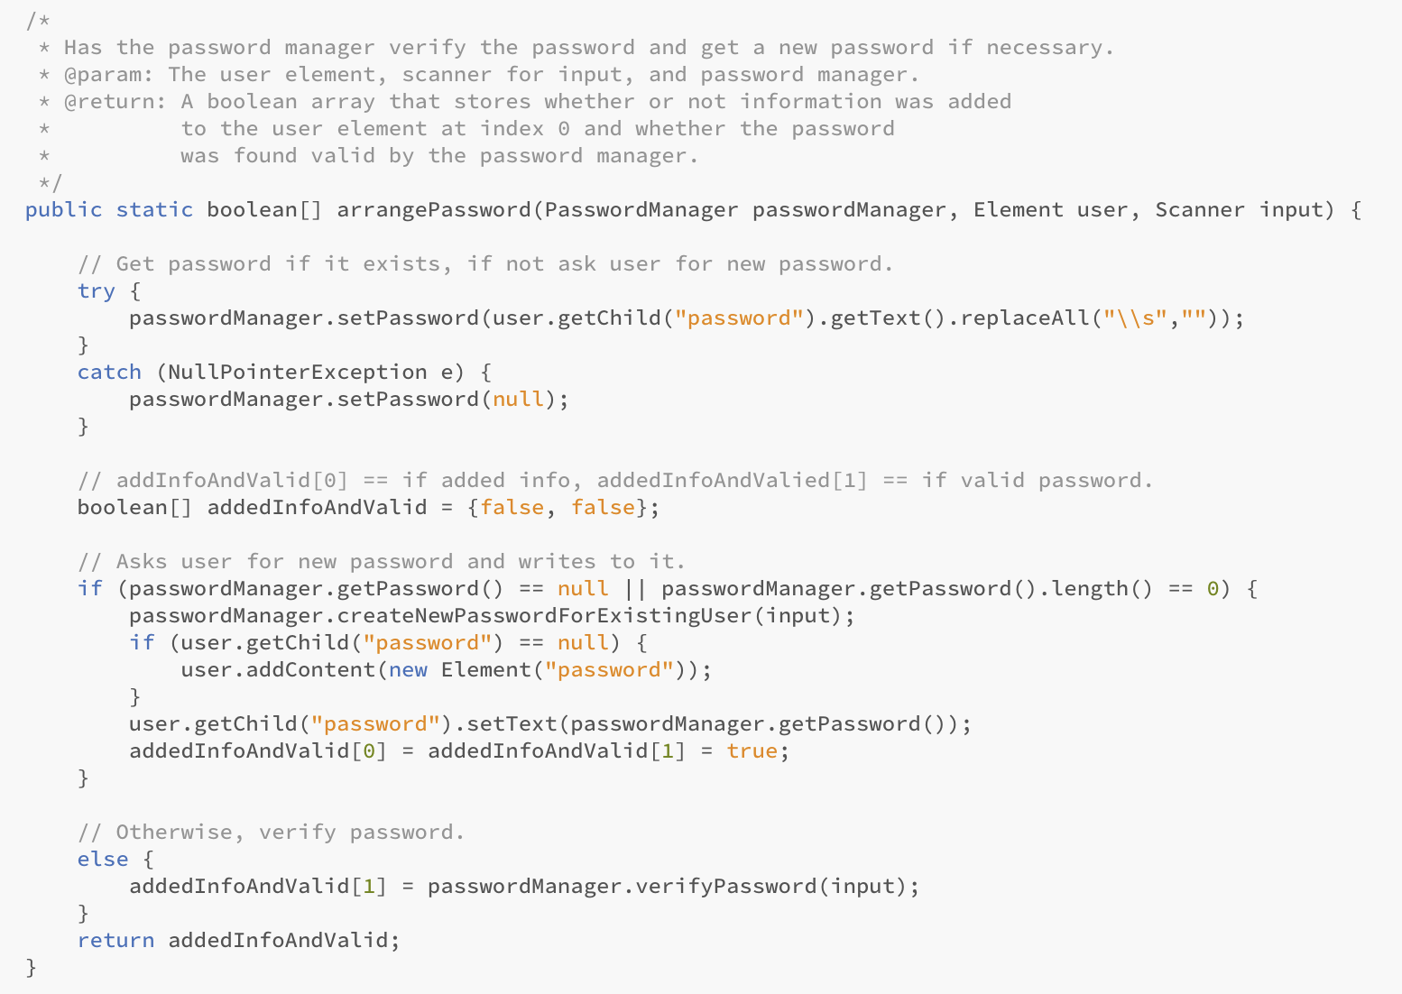

After the user has been created as a ChessPlayer, the controller creates a new game. The controller then determines whether or not a new game needs to be created or a game should be loaded. If the user is new, then a new game is automatically created. Otherwise, the GameSelector is called. If the user wants to load a game, the GameSelector takes the player’s id queue and pops the three elements at the tail into an arraylist. The user selects which game they want to load, and the games are inserted back at the tail in their original position. However, the element that the user selected is now moved to the tail of the list.

pickGameToLoad() from GameSelector.java

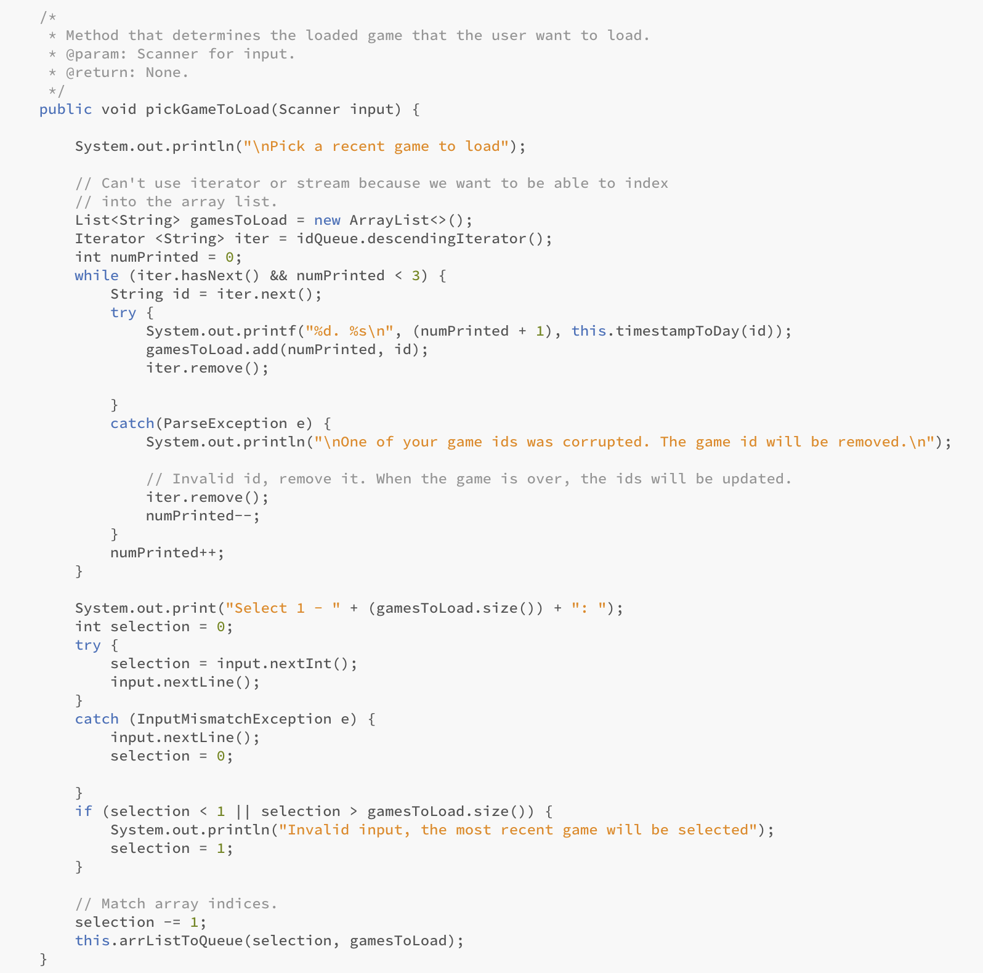

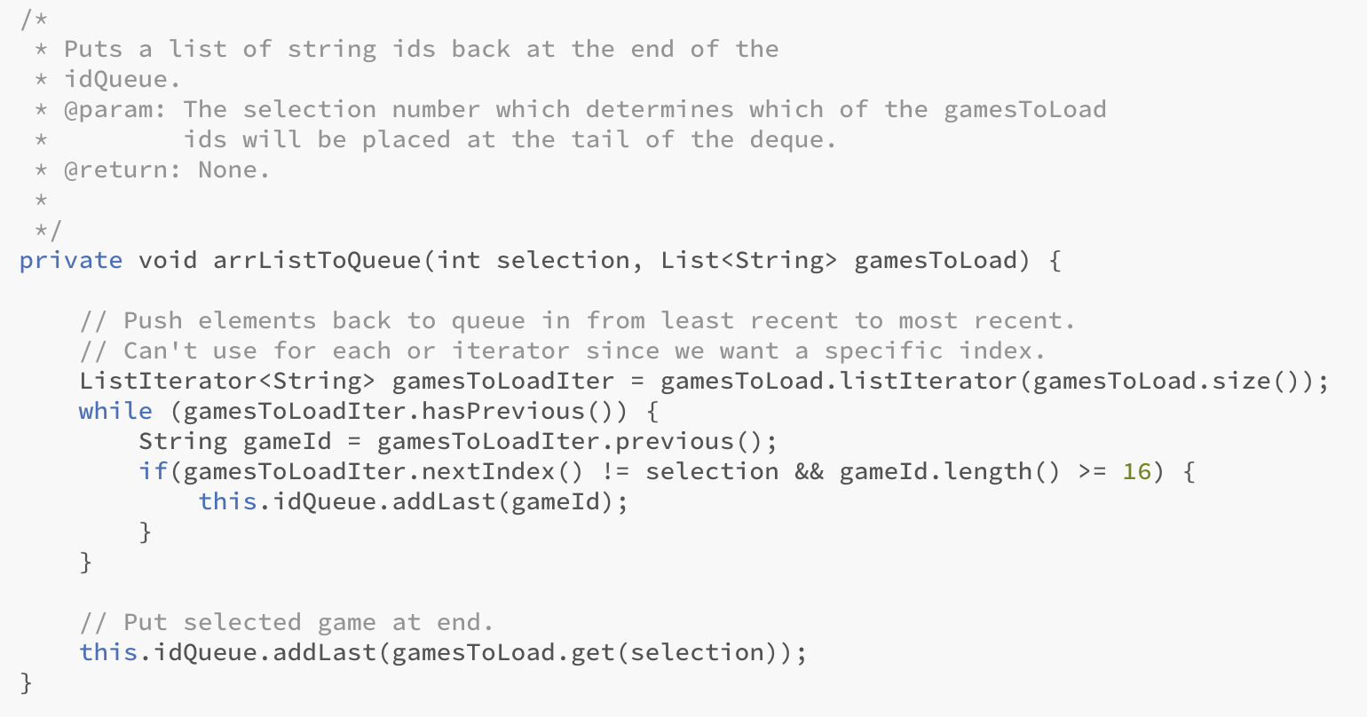

If the user wants to create a new list, the GameSelector first identifies if the user has less than 7 games. If they do, then a new game will be created. Otherwise, the GameSelector calls the GameDeleter. The GameDeleter uses the deleteUserSelectedGames method to remove elements from the deque that the user wants to remove. These elements are then added to the hash set of games to delete.

deleteUserSelectedGames() from GameDeleter.java

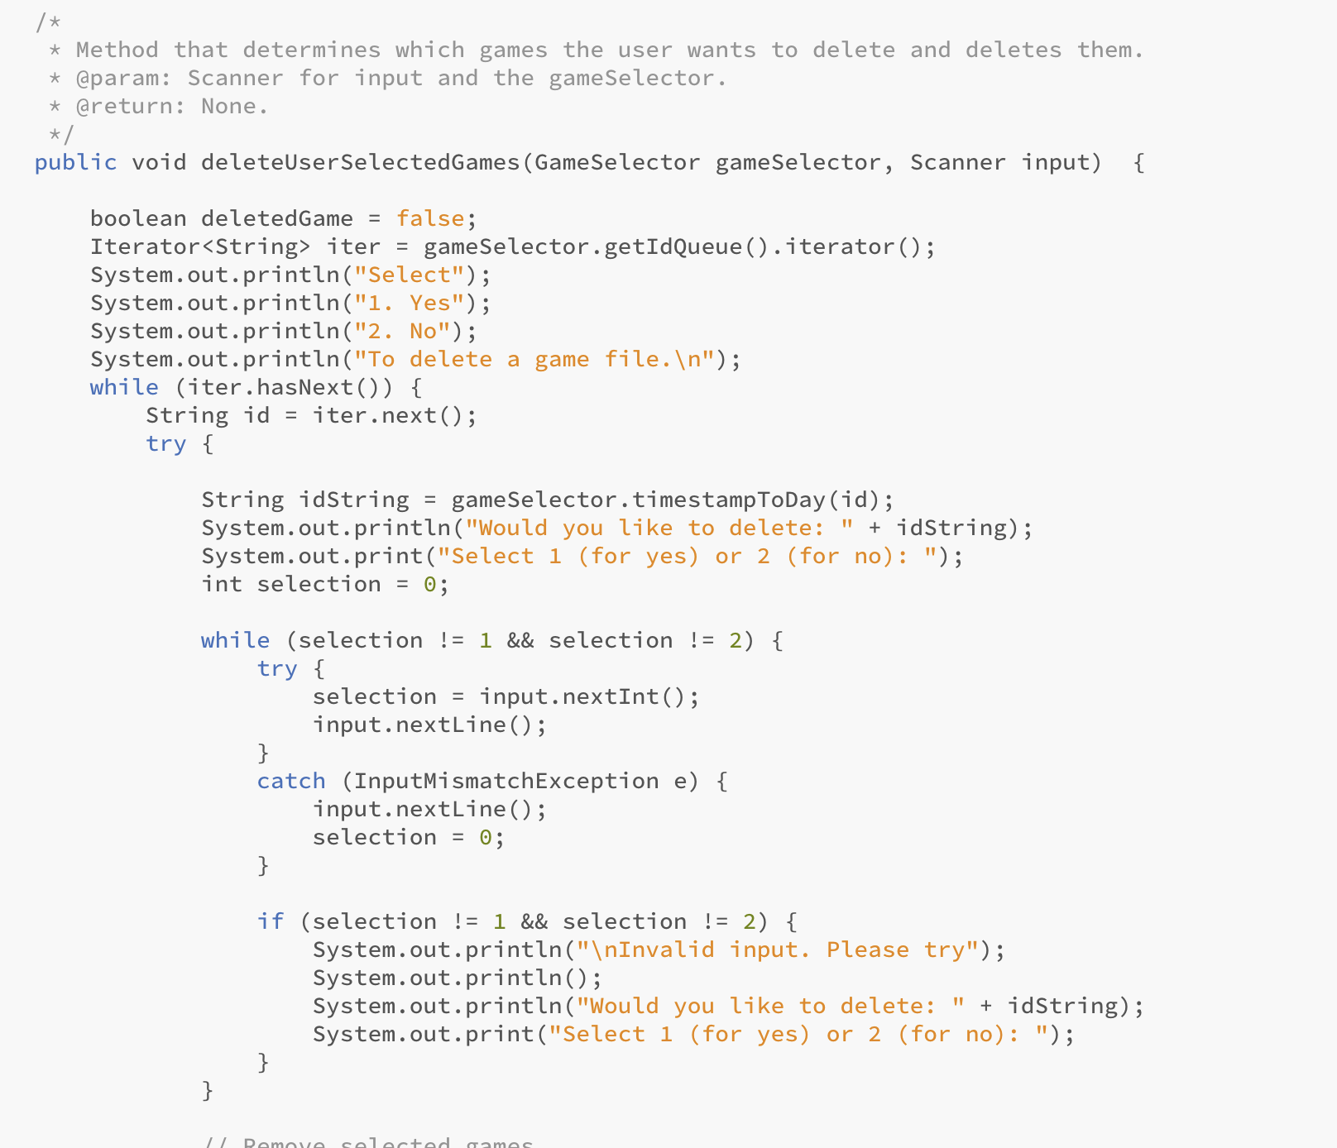

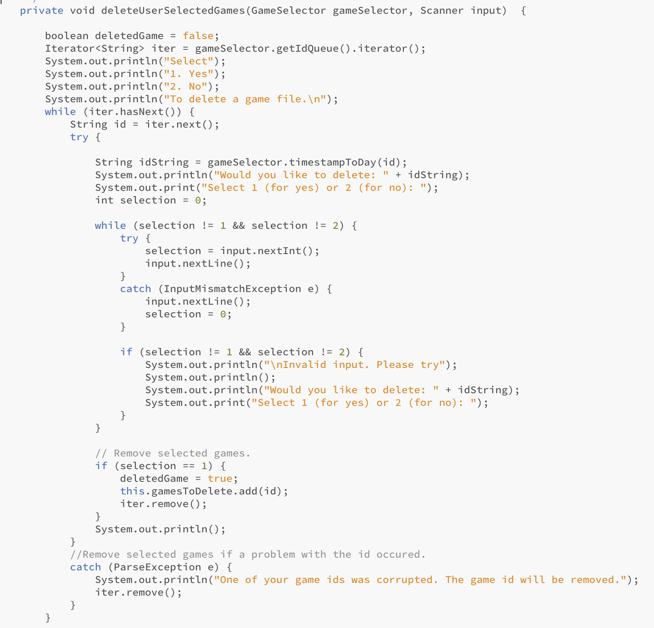

After the user makes their selection, the GameDeleter looks at the config file and iterates through its elements by using an iterator. If the game id is contained in the hash set, then that element is removed from the XML file. The chess template for that game is also removed. After the controller knows whether the game is going to be new or a loaded game, the game creation begins. The Controller calls the ParserReader to build the game based off the game config and the chess template. When reading the chess template and adding the pieces to the board, a for each loop is used to iterate through the piece elements.

populateBoard() from ParserReader.java

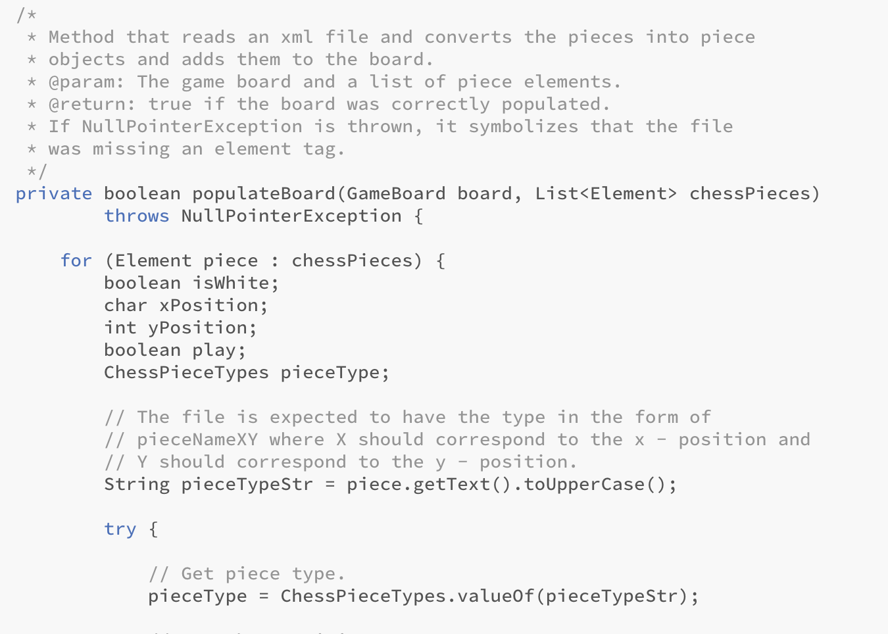

After the board has been populated, the GameController calls the Game’s startGame method. The startGame method really demonstrates the use of the MVC design pattern. Game, which acts as the controller, calls the GameView to display the current chessboard. Game passes in the chess board from the GameModel. Then Game has the GameView collect the current and new x and y positions from the user. The Game then hands these positions to the GameModel to verify and move the piece if possible.

startGame() from Game.java

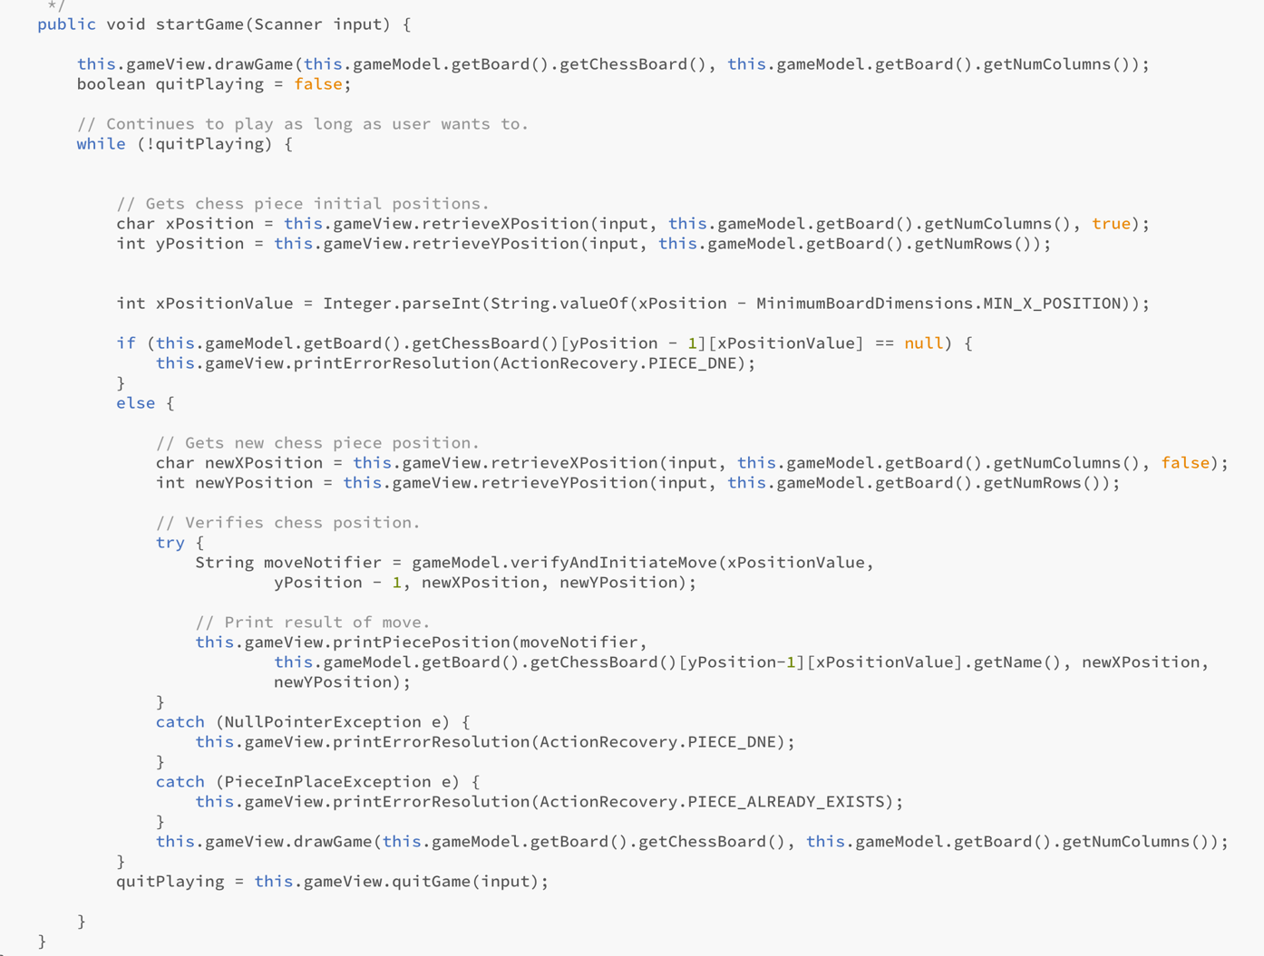

selectX() from GameView.java

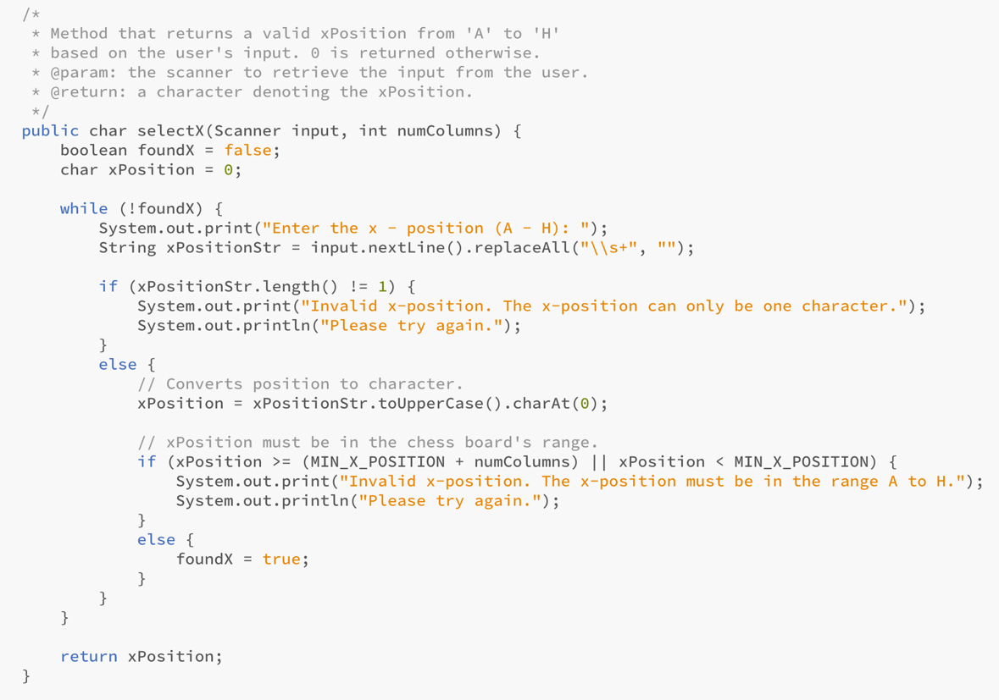

In the verifyAndInitiateMove method, the GameModel calls the move function on the chess piece based on the x and y positions. If a piece already exists in the new x and y positions, then a PieceInPlaceException is thrown. Otherwise, GameModel returns “not” if the piece could not move to the position or “” if the piece could and consequently did move.

verifyAndInitiateMove() from GameModel.java

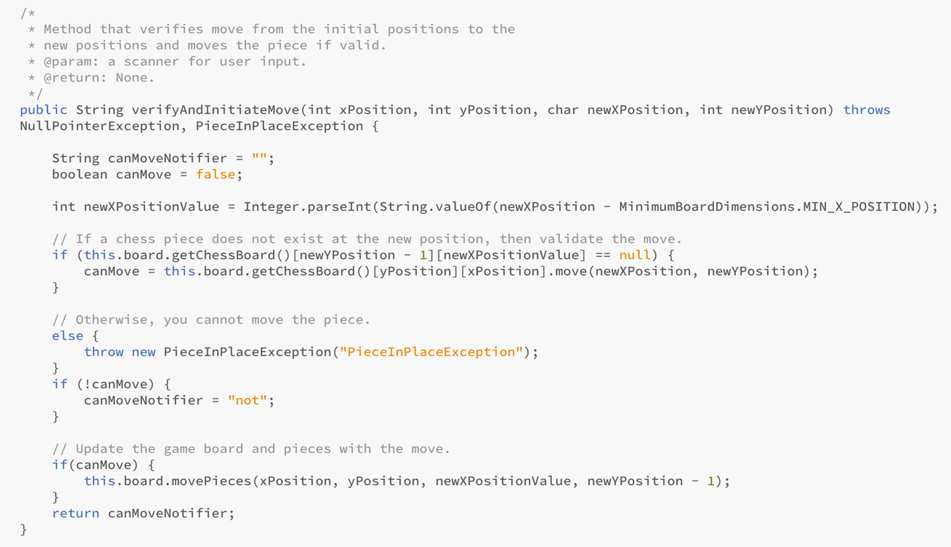

Game will then take this returned string and pass it to the view to print out whether or not the piece could be moved. If an error occurred, then Game also hands the exception to the GameView to print out. Game will then have the GameView collect from the user whether or not they would like to continue playing. If the user selects no, then the Game ends. Controller will then ask the user if they would like to save their game, if the user did not select auto save. If the user is an existing user, ParserWriter will be called to update the user ids. The program will then terminate.

As for the move method, the final template method in the ChessPiece class will be called. The method first checks if the piece moved. Then the abstract validMove method will be called. The current instance’s valid move method will be called and return a Boolean value to the template move method. If the move is valid, the piece’s x and y position will be updated. The name of the piece will also be updated and true will be returned. Otherwise, false will be returned. For more details on the test, collections, or design patterns used, please review their corresponding sections listed above.

validMove() and move() from ChessPiece.java

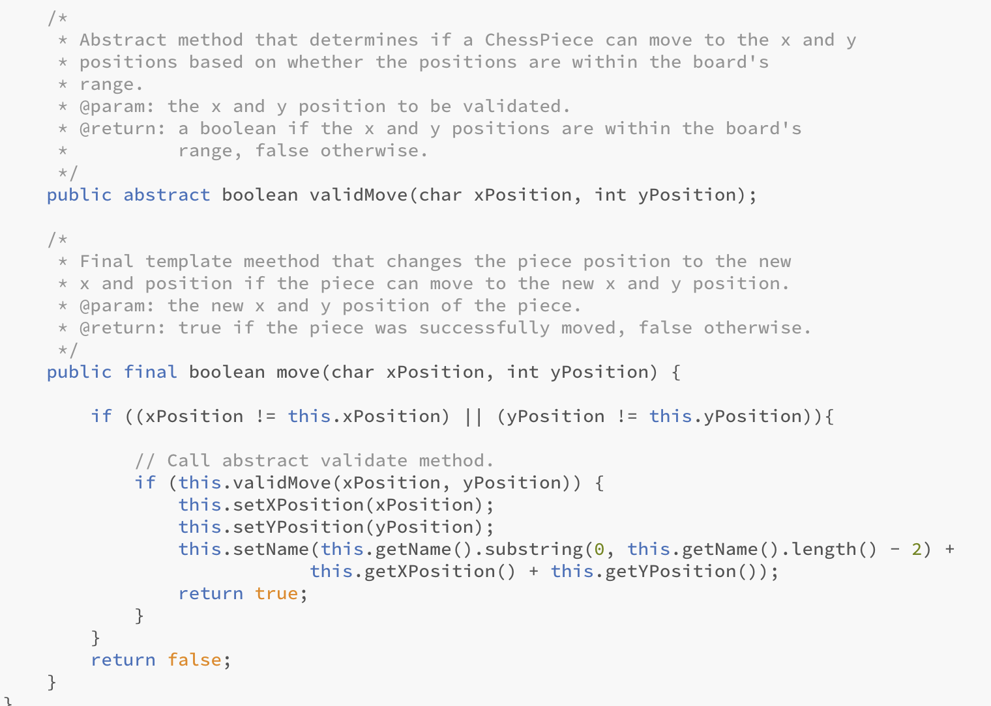

validMove() from Queen.java

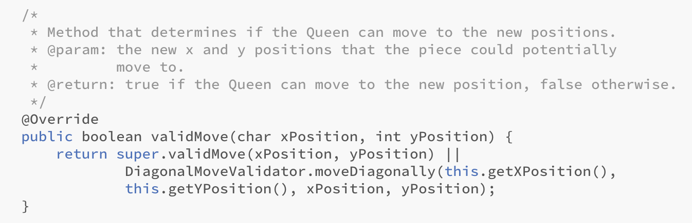

# Test Results from TestSuiteRunner.java

**UNIT TESTS FOR USER CREATOR**

[junit] Running arrangePasswordEmptyPassword

Your password could not be located.

Please enter a new password.

All passwords will have their white space stripped if you include them.

Password:

[junit] Test Complete

[junit] Running arrangePasswordNoPasswordAndSpaces

Your password could not be located.

Please enter a new password.

All passwords will have their white space stripped if you include them.

Password:

[junit] Test Complete

[junit] Running arrangePasswordInitialInValidPassword

Enter your password: Invalid password. Number of attempts left: 4

Password: Valid password. Logging on.

[junit] Test Complete

[junit] Running arrangePasswordNoPassword

Your password could not be located.

Please enter a new password.

All passwords will have their white space stripped if you include them.

Password:

[junit] Test Complete

[junit] Running arrangePasswordInValidPasswordCompletely

Enter your password: Invalid password. Number of attempts left: 4

Password: Invalid password. Number of attempts left: 3

Password: Invalid password. Number of attempts left: 2

Password: Invalid password. Number of attempts left: 1

Password: Invalid password. Number of attempts left: 0

Password:

Maximum password tries were exceeded. Try again later

[junit] Test Complete

[junit] Running arrangePasswordValidPassword

Enter your password: Valid password. Logging on.

[junit] Test Complete

--------------------------

Number of Tests Run: 6

Number of Test Failures: 0

All tests passed: true

--------------------------

**UNIT TESTS FOR GAME SELECTOR**

[junit] Running pickGameToLoadInvalidID

Pick a recent game to load

1. 2020-04-29 20:55:00:529

One of your game ids was corrupted. The game id will be removed.

2. 2020-04-29 20:55:46:624

Select 1 - 2:

[junit] Test Complete

[junit] Running pickGameToLoadFirstElement

Pick a recent game to load

1. 2020-04-30 20:04:39:309

2. 2020-04-29 20:55:00:529

3. 2020-04-29 20:55:46:624

Select 1 - 3:

[junit] Test Complete

[junit] Running pickGameToLoadLastElement

Pick a recent game to load

1. 2020-04-30 20:04:39:309

2. 2020-04-29 20:55:00:529

3. 2020-04-29 20:55:46:624

Select 1 - 3:

[junit] Test Complete

[junit] Running pickGameToLoadCenterElement

Pick a recent game to load

1. 2020-04-30 20:04:39:309

2. 2020-04-29 20:55:00:529

3. 2020-04-29 20:55:46:624

Select 1 - 3:

[junit] Test Complete

[junit] Running pickGameToLoadInvalidSelection

Pick a recent game to load

1. 2020-04-29 20:55:00:529

2. 2020-04-29 20:55:46:624

Select 1 - 2: Invalid input, the most recent game will be selected

[junit] Test Complete

[junit] Running pickGameToLoadLessThanThree

Pick a recent game to load

1. 2020-04-29 20:55:00:529

2. 2020-04-29 20:55:46:624

Select 1 - 2:

[junit] Test Complete

--------------------------

Number of Tests Run: 6

Number of Test Failures: 0

All tests passed: true

--------------------------

**UNIT TESTS FOR GAME DELETER**

[junit] Running getGamesToDeleteNoSelection

Select

1. Yes

2. No

To delete a game file.

Would you like to delete: 2020-04-29 20:55:46:624

Select 1 (for yes) or 2 (for no):

Would you like to delete: 2020-04-29 20:55:00:529

Select 1 (for yes) or 2 (for no):

Would you like to delete: 2020-04-30 20:04:39:309

Select 1 (for yes) or 2 (for no):

You did not select any games to delete. Your oldest game will be deleted

[junit] Test Complete

[junit] Running getGamesToDeleteSetCheck

Select

1. Yes

2. No

To delete a game file.

Would you like to delete: 2020-04-29 20:55:46:624

Select 1 (for yes) or 2 (for no):

Would you like to delete: 2020-04-29 20:55:00:529

Select 1 (for yes) or 2 (for no):

Would you like to delete: 2020-04-30 20:04:39:309

Select 1 (for yes) or 2 (for no):

[junit] Test Complete

[junit] Running getGamesToDeleteAll

Select

1. Yes

2. No

To delete a game file.

Would you like to delete: 2020-04-29 20:55:46:624

Select 1 (for yes) or 2 (for no):

Would you like to delete: 2020-04-29 20:55:00:529

Select 1 (for yes) or 2 (for no):

Would you like to delete: 2020-04-30 20:04:39:309

Select 1 (for yes) or 2 (for no):

[junit] Test Complete

[junit] Running deleteUserSelectedGamesDequeCheck

Select

1. Yes

2. No

To delete a game file.

Would you like to delete: 2020-04-29 20:55:46:624

Select 1 (for yes) or 2 (for no):

Would you like to delete: 2020-04-29 20:55:00:529

Select 1 (for yes) or 2 (for no):

Would you like to delete: 2020-04-30 20:04:39:309

Select 1 (for yes) or 2 (for no):

[junit] Test Complete

[junit] Running getGamesToDeleteBadID

Select

1. Yes

2. No

To delete a game file.

Would you like to delete: 2020-04-29 20:55:46:624

Select 1 (for yes) or 2 (for no):

One of your game ids was corrupted. The game id will be removed.

[junit] Test Complete

--------------------------

Number of Tests Run: 5

Number of Test Failures: 0

All tests passed: true

--------------------------

**UNIT TESTS FOR GAME MODEL**

[junit] Running verifyAndInitiateMovePieceAlreadyExists

[junit] Test Complete

[junit] Running verifyAndInitiateMoveInValidMove

[junit] Test Complete

[junit] Running verifyAndInitiateMovePieceDNE

[junit] Test Complete

[junit] Running verifyAndInitiateMoveValidMove

[junit] Test Complete

[junit] Running verifyAndInitiateMovePieceMoved

[junit] Test Complete

--------------------------

Number of Tests Run: 5

Number of Test Failures: 0

All tests passed: true

--------------------------

**UNIT TESTS FOR QUEEN**

[junit] Running outOfBoundsXPosition

Enter the x - position (A - H): Invalid x-position. The x-position must be in the range A to H.Please try again.

Enter the x - position (A - H): Invalid x-position. The x-position must be in the range A to H.Please try again.

Enter the x - position (A - H): Invalid x-position. The x-position must be in the range A to H.Please try again.

Enter the x - position (A - H): Invalid x-position. The x-position must be in the range A to H.Please try again.

Enter the x - position (A - H): Invalid x-position. The x-position must be in the range A to H.Please try again.

Enter the x - position (A - H):

[junit] Test Complete

[junit] Running validMoveVertical

[junit] Test Complete

[junit] Running invalidMoveLShape

[junit] Test Complete

[junit] Running validMoveDiagonal

[junit] Test Complete

[junit] Running outOfBoundsYPosition

Enter the y - position (1 - 8): Invalid input. The y-position can only be an integer. Please try again

Enter the y - position (1 - 8):

Invalid y-position. The y-position must in the range of 1 to 8. Please try again.

Enter the y - position (1 - 8):

Invalid y-position. The y-position must in the range of 1 to 8. Please try again.

Enter the y - position (1 - 8):

Invalid y-position. The y-position must in the range of 1 to 8. Please try again.

Enter the y - position (1 - 8): Invalid input. The y-position can only be an integer. Please try again

Enter the y - position (1 - 8): Invalid input. The y-position can only be an integer. Please try again

Enter the y - position (1 - 8):

[junit] Test Complete

[junit] Running invalidMoveSlantedDiagonal

[junit] Test Complete

[junit] Running validMoveHorizontal

[junit] Test Complete

--------------------------

Number of Tests Run: 7

Number of Test Failures: 0

All tests passed: true

--------------------------